The West of Scotland Open returned to the Scotstoun Sports Camps on Saturday 28th and Sunday 29th January 2017, with 100 competitors taking part over the weekend, high quality table tennis and plenty of shocks were the order of the day.
Men’s Singles
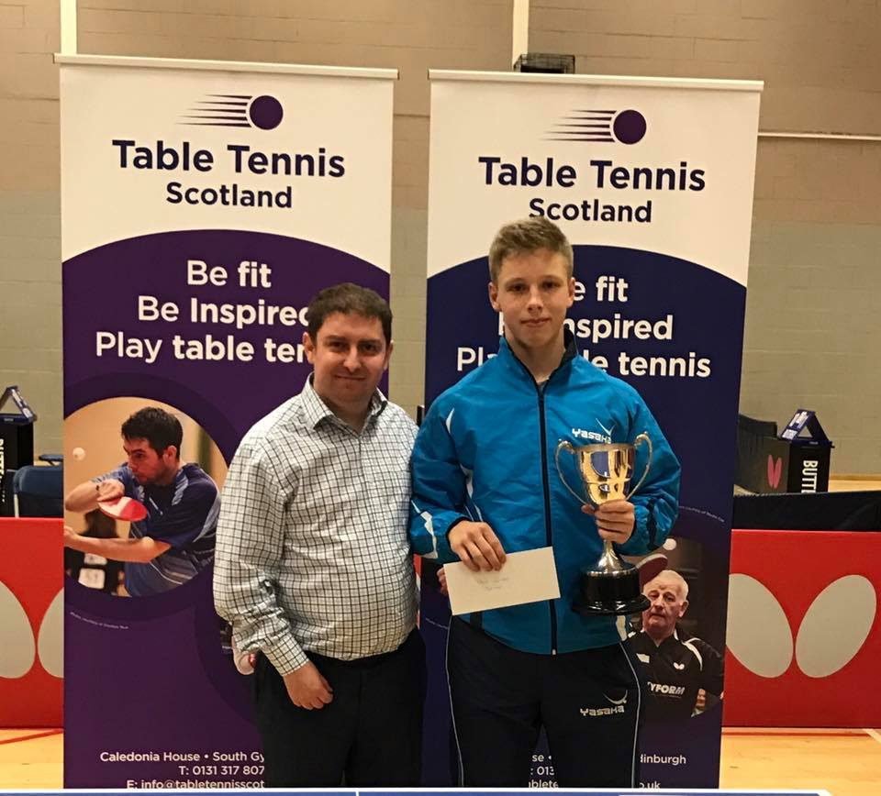
Men’s Singles Champion – Oscar Perman
Oscar Perman cruised his way through group 1 defeating Tam Lawlor, Derek Lundie and Jiamin Chen, Jiamin Chen finished runner up after two five setters with Derek Lundie and Tam Lawlor. In Group 2, Colin Dalgleish accounted for Stewart Armitage, Charlie Morton and Conor McAdam. Charlie Morton caused the upset in this group accounting for Stewart Armitage. Group 3 and the first major seed to fall in the Men’s Singles event saw Ethan Chapman score a great 3-2 victory over Chris Wheeler, Chris was to finish runner up. In Group 4 Calum Main won this group with Sepehr Bidari as runner up. Sean Doherty topped group 5 with Andy McFadyen finishing runner up. Niall Cameron was the inner of group 6 and Danny Bajwa was the runner up. Victor Shi Guang was winner in group 7 with Martin Johnson was runner up. Group 8 saw yet another upset with Calum Morrison accounting for Scott Barton. John Hannah then accounted for another seed in group 9 when he defeated John Hannah.
Preliminary ties saw Scott Barton defeat Danny Bajwa 3-0 (13-11, 11-3, 11-3) and Yaser Razouk defeated Andy McFadyen 3-0 (12-10, 11-5, 11-8).
In the last 16, Oscar Perman entertained the crowd with a 3-0 win over Scott Barton (11-4, 11-7, 11-6). Sean Doherty defeated Sepehr Bidari 3-1 (11-8, 11-9, 9-11, 11-6). Victor Shi Guang accounted for John Hannah 3-0 (11-7, 11-9, 11-8). Ethan Chaman then continued his good run with a 3-1 win over Charlie Morton 3-1 (6-11, 11-8, 11-7, 11-7). Calum Main defeated Martin Johnston 3-0 (11-5, 11-6, 11-8). Niall Cameron took no chances in his encounter with Jiamin Chen winning 3-0 (11-6, 12-10, 11-5). Calum Morison then scored a very good win over Chris Wheeler 3-2 (9-11, 11-3, 11-4, 13-15, 12-10) and finally Colin Dalgleish scored a 3-0 over Yaser Razouk (11-6, 11-8, 11-8)
So the quarter final line saw Oscar Perman defeat Sean Doherty 3-0 (11-8, 11-6, 11-6) Victor Shi Guang ended Ethan Chapmans good run with a 3-1 win (11-3, 11-2, 8-11, 11-3) Niall Cameron then upset Calum Main winning 3-0 (11-4, 11-9, 13-11) and Colin Dalgleish ended Calum Morrison’s run winning 3-1 (11-6, 11-9, 10-12, 13-11)
The first of the semi-finals saw Oscar Perman tested against Victor Shi Guang in a very entertaining encounter in which Oscar won 3-1 (12-10, 11-5, 6-11, 11-9). Colin Dalgleish then survived a five set marathon match against Niall Cameron winning 3-2 (11-9, 14-16, 8-11, 12-10, 11-8)
The final of the Men’s Singles was then between number 1 seed Oscar Perman and number 2 seed Colin Dalgleish. Oscar got off to a good start winning the first set 11-8, however Colin then won the second and third sets 11-6, 11-5, Oscar hen came back strong to win the fourth set 11-6 and after some great rallies won the fifth set 11-6
Ladies Singles
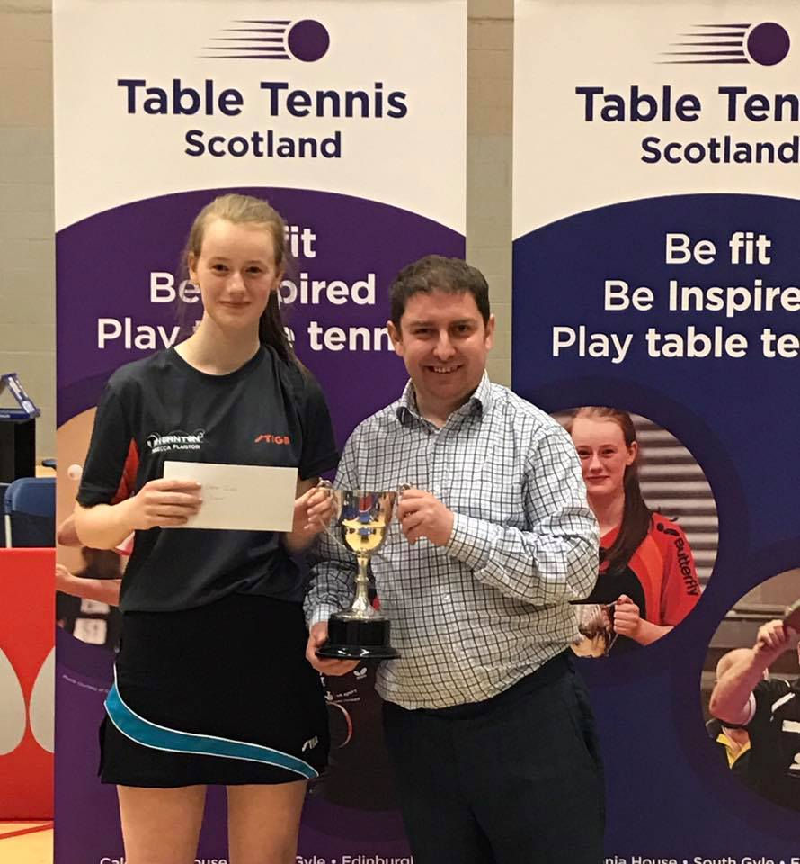
Ladies Singles Champion – Rebecca Plaistow
Group 1 saw top seed Gillian Edwards defeated by cadet Tessa Yau and Lara Stirling. Lara was then to defeat Tessa to win the group and Tessa was runner up. Group 2 saw a similar situation with Lucy Elliott defeating number 2 seed Ashley Givan (Ireland) with Ashley being the runner up. Group 3 saw Lynda Flaws being the winner with Rebecca Plaistow as the runner up.
Preliminary ties saw Rebecca Plaistow win 3-1 against Ashley Givan (7-11, 14-12, 12-10, 11-6) and Lynda Flaws defeat Tessa Yau 3-0 (11-9, 11-8, 11-9)
In the first semi-finals, Rebecca Plaistow had to battle hard in her encounter with Lara Stirling. Lara raced to a 2-0 lead only for Rebecca to come back strong winning the match 3-2 (6-11, 8-11, 11-7, 11-8, 11-9). Lynda Flaws then recovered well to book her place in the final with a 3-1 win over Lucy Elliott (10-12, 11-7, 11-7, 11-7)
The final was a rematch from earlier in group 3 with Rebecca Plaistow facing Lynda Flaws. This time Rebecca got her revenge to win her Senior Women’s title at the West of Scotland Open winning 3-1 (7-11, 11-8, 13-11, 11-8).
Band 1
Band 1 Champion – Martin Johnson
The band 1 event had its own upsets and it started with group 1 with Andrew MacPherson scoring a great 3-0 win over top seed Calum Morrison, Calum was to finish runner up. Group 2 was to be no different with Zaid Khalid accounting for number 2 seed John Hannah, with John finishing runner up. Danny Bajwa won group 3 with wins over Peter Cameron, Charlie Morton, Thomas Cairns and Ashley Givan. More upsets came in group 4 with Martin Johnston winning against Andy McFadyen. Ethan Chapman then continued his form from the Men’s Singles to upset Rebecca Plaistow in group 5.
In the preliminary ties, John Hannah defeated Andy McFadyen 3-0 (11-4, 11-8, 11-5) and Charlie Morton defeated Stewart Armitage 3-2 (8-11, 11-4, 8-11, 15-13, 12-10)
In the Quarter Finals, John Hannah battled to defeat Andrew MacPherson 3-2 (11-7, 5-11, 8-11, 13-11, 11-6), Danny Bajwa also battled his way through five sets to defeat Ethan Chapman (12-10, 10-12, 14-12, 7-1, 11-7). Martin Johnson then had a fantastic win over Calum Morrison winning 3-2 (6-11, 9-11, 11-5, 12-10, 11-6) and Zaid Khalid accounted for Charlie Morton winning 3-1 (7-11, 11-8, 12-10, 12-10).
In the Semi Finals, John Hannah overcame Danny Bajwa in five sets (8-11, 11-9, 5-11, 11-7, 11-6) and Martin Johnson defeated Zaid Khalid 3-1 (9-11, 11-7, 11-7, 11-9).
In the final, Martin was a worthy winner of the band 1 title winning 3-2 against John Hannah (6-11, 12-10, 11-8, 3-11, 11-9).
Band 2
Band 2 Champion – Harvey McDonald
With the theme of the competition being upsets after upsets, band 2 was to be no different! Conor Gordon upset number 1 seed Charlie Brown to win the Group with Charlie being the runner up. Roy Claxton won group 2 with wins over Tessa Yau, Elliott Medland and Billy Murphy. Harvey McDonald won group 3 with wins over Isla Stott, Declan Tobin and Martin Richen. Derek Lundie was the winner of group 4 with wins over Catherine O’Neill, Euan McLaughlin and David Morrison, Catherine scored a good win over Euan McLaughlin to finish runner up. Davie McDonald won group 5 with wins over Paula Callaghan, Kayser Collins and Kenny Lee.
In the preliminary rounds, Tessa Yau defeated Kenny Lee 3-0 (11-6, 12-10, 11-8) and Charlie Brown defeated Catherine O’Neill 3-0 (11-2, 11-9, 11-6).
In the quarter finals, Tessa Yau scored an excellent 3-0 win over Conor Gordon (11-9, 11-8, 14-12), Derek Lundie won 3-0 against Martin Richens ( 11-8, 11-8, 11-6), Harvey McDonald then won 3-0 against Davie McDonald (11-7, 14-12, 12-10) and Roy Claxton was a 3-1 winner over Charlie Brown (11-5, 11-8, 8-11, 12-10)
The semi-finals saw Derek Lundie end Teesa Yau’s run in the event winning 3-0 (11-7, 11-9, 11-3) and Harvey McDonald defeated his coach Roy Claxton 3-0 (11-7, 11-7, 11-5).
Harvey McDonald was a worthy winner of the band 2 title with a good 3-0 win over Derek Lundie (11-7, 11-8, 11-9)
Veteran Singles
Veterans Champion – Martin Richens and Runner Up Derek Lundie
Roy Claxton topped group 1 with wins over Billy Murphy, Adam Smolarek and Martin Richens. Martin was to be the runner up, Derek Lundie was the winner of group 2, with wins over Peter Cameron and Femi Odusanya, with Peter as runner up. Charlie Brown was the winner of group 3 with wins over Catherine O’Neill, Tam Lawlor (W/O) and James Dickson. Catherine was to be runner up.
In the preliminary ties, Derek Lundie defeated Catherine O’Neill 3-0 (11-6, 11-7, 11-7) and Martin Richens received a walko0ver against Peter Cameron.
In the semi-finals, Derek Lundie scored a good win over number 1 seed Roy Claxton winning 3-0 (11-8, 11-8, 11-8) and Martin Richens defeated Charlie Brown (11-8, 13-11, 11-5).
The final of the veterans saw a rematch from group 3, with Martin Richens taking the title defeating Derek Lundie 3-2 (9-11, 9-11, 11-5, 11-8, 11-5.

Disability Singles
Disability Champion – Martin Perry
Martin Perry got things underway in the disability event winning group 1 against Declan Tobin and David Morrison, Declan then had to battle back from 0-2 down to overcome David Morrison and finish runner up.
The upsets continued in this event with Conor McAdam defeating Conor Gordon and Elliott Medland to win the group with Conor Gordon as runner up. Peter Cameron won group 3 with wins against Euan McLaughlin and Iona McLean, Euan was runner up.
In the preliminary ties, Conor Gordon was a 3-1 winner against Euan McLaughlin (11-9, 8-11, 11-8, 11-8) and Peter Cameron defeated Declan Tobin 3-0 (11-3, 11-2, 11-5)
The semi-finals saw Martin Perry winning 3-1 against Conor Gordon (11-13, 12-10, 11-6, 11-6) and Conor McAdam overcome Peter Cameron in an action packed five set thriller (7-11, 10-12, 11-6, 11-4, 11-4).
The final of this event saw number 1 seed Martin Perry who is currently training full time in Sheffield up against Conor McAdam who has moved to train full time at Grantham College. Martin used his experience to win the title winning 3-1 (11-8, 11-9, 9-11, 11-8).

Men’s Doubles
Men’s Doubles Champions – Scott Barton and Colin Dalgleish
In the preliminary ties, Peter Cameron/Thomas Cairns won 3-0 against Euan McLaughlin/Conor McAdam (11-2, 11-6, 11-9) and Danny Bajwa/Martin Johnson scored a good 3-0 win over Victor Shi Guang/Luke Tattersall (11-5, 11-6, 12-10).
In the quarter finals, Chris Wheeler/Calum Main defeated Peter Cameron/Thomas Cairns 3-0 (12-10, 11-7, 11-9). Colin Dalgleish/Scott Barton were 3-1 winners against Oscar Perman/Sepehr Bidari (9-11, 11-4, 11-4, 11-9). Yaser Razouk/Calum Morrison were 3-0 winners over Ethan Chapman/Andrew MacPherson (11-5, 13-11, 11-7) and Sean Doherty/Niall Cameron won 3-0 against Danny Bajwa/Martin Johnson (11-3, 11-3, 12-10)
In the semi-finals, Colin Dalgleish/Scott Barton defeated top seeds Chris Wheeler/Calum Main (12-10, 11-9, 11-9). In the other semi-final Sean Doherty/Niall Cameron overcame the junior team of Yaser Razouk/Calum Morrison 3-1 (11-5, 11-9, 13-15, 11-6.
Congratulations to Colin Dalgleish/Scott Barton who added the West Open Doubles title to their National Doubles title with a 3-0 win over Sean Doherty/Niall Cameron (11-9, 11-7, 11-9).

Ladies Doubles
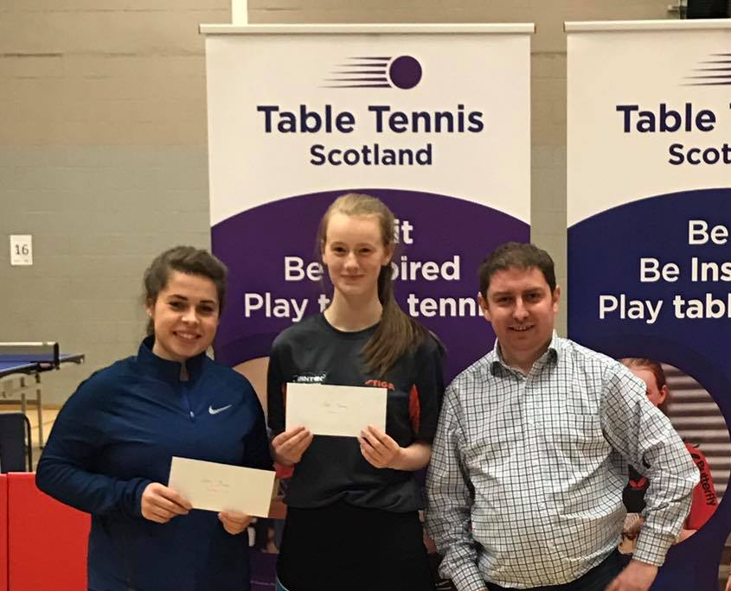
Ladies Doubles Champions – Lynda Flaws and Rebecca Plaistow
In the preliminary tie, Corinna Whitaker/Linda McLernon defeated Catherine O’Neill/Senga Thomson 3-0 (11-9, 11-2, 11-2).
In the semi finals, Lynda Flaws/Rebecca Plaistow won 3-0 against Corinna Whitaker/Linda McLernon (9-11, 11-7, 11-6, 11-1) and Lara Stirling/Rachel Crawford were 3-1 winners over Lucy Elliott/Paula Callaghan (11-6, 7-11, 11-7, 11-9).
Congratulations to Lynda Flaws and Rebecca Plaistow on winning the title defeating Lara Stirling/Rachel Crawford 3-2 (11-8, 6-11, 11-5, 4-11, 11-9).

