After all the shocks and surprises of day 1 at the West of Scotland 2017, would day 2 give us as many shocks and surprises. Well the simple answer is Yes! So, let’s get underway
Junior Boys Singles
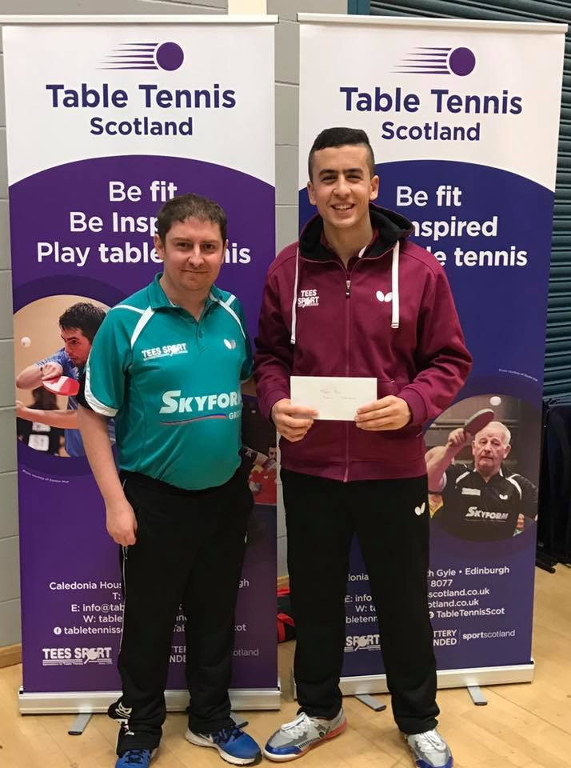
Junior Boys Champion – Yaser Razouk
With the withdrawal of number 1 seed Christopher Wheeler, group 1 was won by Harvey McDonald with Kayser Collins as the runner up. Martin Johnson caused the next upset by scoring another victory over number 2 seed Calum Morrison 3-2 (8-11, 11-8, 12-10, 3-11, 11-6). Yaser Razouk won group 3 defeating Robyn Wilson, Michael Zhang and Chris Mexson. Ethan Chapman was the group 4 winner defeating Rafal Wilwoski, Elliott Medland and Tony Nelson with Rafal being runner up. Group 5 was won by Danny Bajwa with Charlie Morton as runner up , group 6 was won by Zaid Khalid with James Woods as runner up and finally group 7 was won by James Forrest defeating Elias Bokedal.
The last 16 stage saw Harvey McDonald and Martin Johnson receiving byes into the quarter finals. Zaid Khalid defeated Michael Zhang 3-0 (11-7, 8-11, 11-8, 11-7) Calum Morrison won 3-1 against Elias Bokedal (11-6, 10-12, 11-5, 11-7). Ethan Chapman had to stage a strong comeback to win 3-2 against Charlie Morton (7-11, 11-5, 11-4, 9-11, 11-7). Yaser Razouk defeated Kayser Collins 3-0 (11-5, 11-1, 11-4). Danny Bajwa was a 3-0 winner against James Woods (11-8, 11-6, 11-4) James Forrest defeated Rafal Wilowski 3-0 (11-7, 11-9, 11-5).
In the quarter finals, Harvey McDonald defeated Zaid Khalid 3-2 (7-11, 5-11, 11-9, 11-6, 11-9), Calum Morrison defeated Ethan Chapman 3-1 (12-10, 11-6, 10-12, 11-7. Yaser Razouk was almost the next casualty having to save match point from Danny Bajwa before winning 3-2 (11-7, 12-10, 20-12, 9-11, 12-10) and Martin Johnson won 3-1 against James Forrest (9-11, 11-4, 11-5, 11-5).
In the first semi-finals Calum Morrison was a 3-0 winner against Harvey McDonald (11-7, 11-8, 11-7) and Yaser Razouk was a 3-0 winner against Martin Johnson (13-11, 11-7, 11-3).
Congratulations to Yaser Razouk on winning the Junior Boys title defeating Calum Morrison 3-1 in the final (8-11, 11-6, 12-10, 11-6).
Junior Girls Singles
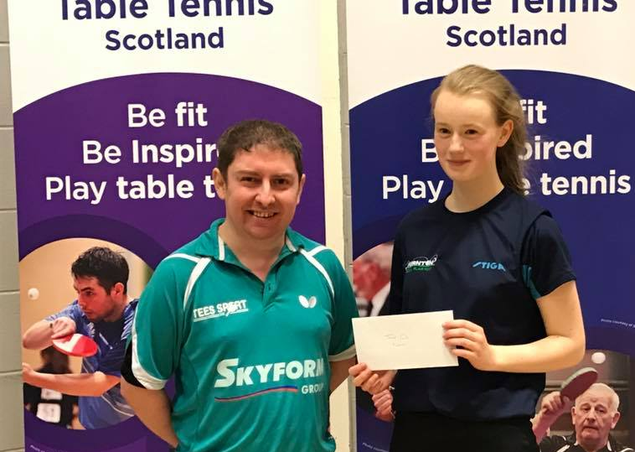
Rebecca Plaistow - Junior Girls Champion
The Junior Girls event started off with its own shocks and surprises as Jennie Yang defeated number 1 seed Rebecca Plaistow to win group 1, Rebecca finished runner up. Isla Stott continued the upsets with a 3-1 win over Alisa Khalid. Tessa Yau was the group 3 winner defeating Wiktoria Smolarek and Holly Stephens.
In the preliminary ties Alisa Khalid defeated Tessa Yau 3-0 (11-9, 11-8, 11-9) and Rebecca Plaistow defeated Wiktoria Smolarek 3-0 (11-4, 11-8, 11-8).
The first semi-final saw Alisa Khalid win 3-0 against Jennie Yang (11-5, 11-9, 11-7) and Rebecca Plaistow saw off Isla Stott winning 3-0 (11-4, 11-2, 11-8)
Rebecca Plaistow was to add the junior girls title to her Senior Singles and Doubles titles from day 1 by defeating Alisa Khalid 3-0 (12-10, 13-11, 11-6).
Cadet Boys Singles
Martin Johnson – Cadet Boys Champion
Martin Johnson was the winner of group 1 defeating Guatama Kakar, Michael Zhang and Luke Hennessey. Group 2 was Won by Danny Bajwa with Rafal Wilowski as runner up. Group 3 was won by Zaid Khalid with Charlie Morton being the runner up. Yifei Fang upset number 4 seed by defeating James Forrest. Group 6 was won by Harvey McDonald, Elliott Medland was the runner up by defeating Rayaan Khalid and Adam Darugar.
In the preliminary ties, James Forrest defeated Rafal Wilowski 3-1 (11-5, 11-6, 8-11, 11-6) and Charlie Morton won 3-0 against Elliott Medland (11-2, 11-6, 11-4).
At the quarter final stage, Martin Johnson ran out a 3-0 winner against James Forrest (11-8, 11-5, 11-7). Harvey McDonald won 3-1 against Zaid Khalid (11-5, 11-9, 8-11, 11-8) Yifei Fang won 3-0 against Guatam Kakar (11-8, 11-8, 11-8) and Danny Bajwa was a 3-0 winner against Charlie Morton (11-8, 11-6, 11-5)
In an all Ayrshire semi-final, Martin Johnson was a 3-0 winner against Harvey McDonald (11-9, 11-7, 11-5). Completing the line-up for the final was Danny Bajwa who defeated Yifei Fang 3-0 (11-4, 11-8, 14-12)
In the Final Martin Johnson added the cadet boys title to his Men’s band 1 title as he defeated Danny Bajwa 3-0 (11-9, 11-3, 11-8)
Cadet Girls Singles
Cadet Girls Champion – Jennie Yang
Tessa Yau was the winner of Group 1, defeating Paula Callaghan and Amelia Norbury. Jennie Yang won group 2 with wins over Catrin Ace and Holly Stephens and Wiktoria Smolarek won group 3 with wins over Shannon Brown and Charlotte Burridge.
In the preliminary ties, Wiktoria Smolarek was a 3-1 winner over Catrin Ace (10-12, 13-11, 11-1, 11-5). Paula Callaghan the defeated Charlotte Burridge 3-0 (11-1, 11-2, 11-4).
Wiktoria Smolarek then caused yet another upset by defeating number 1 seed Tessa Yau 3-1 (11-8, 12-10, 6-11, 11-4). Paula Callaghan then almost caused another upset in her match with Jennie Yang and led 7-3 in the final set only for Jennie to show her determination to come back strong to win the match 3-2 (7-11, 11-8, 6-11, 11-8, 11-8).
So, it was to be an all Drumchapel final between Jennie Yang and Wiktoria Smolrek and Jennie ran out a comfortable winner winning the match 3-0 (11-6, 13-11, 11-7).
Minor Boys Singles
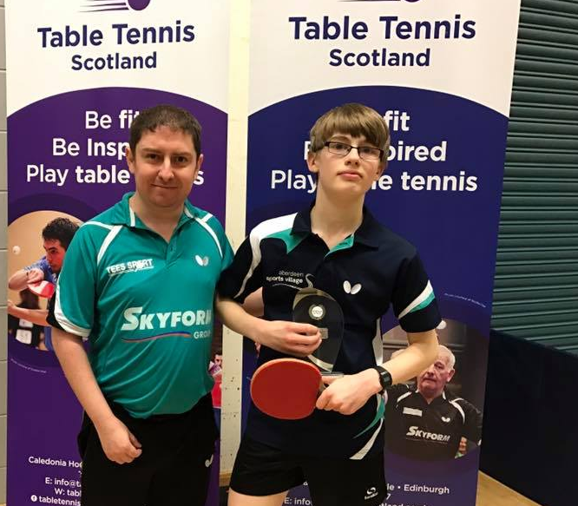
Minor Boys Champion – Josef Bokedal
Jamie Johnson ran out the winner in Group 1 with wins over Joseph McAneny and Finlay Zanna. Josef Bokedal won group 2 with wins over Patric Hollywood and Nathan Hogg. Rayyan Khalid was the group 3 winner defeating Chad Duncan and Jacob Munro.
In the preliminary tie, Patric Hollywood defeated Chad Duncan 3-2 (11-9, 5-11, 14-16, 11-4, 11-3) and Rayyan Khalid won 3-1 against Finlay Zanna (11-6, 11-7, 7-11, 11-5)
In the semi finals, Jamie Johnson ran out a 3-0 winner against Patric Hollywood (11-5, 11-2, 11-5) and then Josef Bokedal won 3-0 against Rayyan Khalid (11-5, 11-5, 11-6)
Josef Bokedal then caused his own upset by defeating number 1 seed Jamie Johnson to claim the title winning the match 3-0 (11-6, 11-6, 13-11).
Minor Girls Singles
Minor Girls Champion – Holly McNamara
This event was placed in a group of 4 in which Holly McNamara justified her top seeding winning her matches against Amelia Smolarek 3-0 (11-6, 11-9, 13-11), Jessica Hogg 3-0 (11-2, 11-6, 11-4) and Shannon Brown 3-0 (11-4, 11-3, 11-3) Amelia Smolarek finished runner up by defeating Jessica Hogg 3-0 (11-3, 11-2, 11-4) and Shannon Brown 3-0 (11-8, 11-4, 14-12).
Junior Doubles
Junior Doubles Champions – Rebecca Plaistow and Ethan Chapman
In the preliminary ties, Rafal Wiklowski/Elias Bokedal were 3-2 winners against Aaron Richardson/Paula Callaghan (5-11, 11-7, 8-11, 11-6, 11-7). James Woods/Charlie Morton were 3-0 winners against Patric Hollywood/Chad Duncan (11-3, 11-2, 11-7). Guatam Kakar/Jamie Johnson were 3-0 winners against Amelia Norbury/Holly Stephens (11-9, 11-8, 13-11)
In the Quarter Finals, Zai9d Khalid/Yaser Razouk defeated Rafal Wilowski/Elias Bokedal 3-1 (7-11, 11-6, 11-9, 11-3). Ethan Chapman/Rebecca Plaistow won 3-1 against James Woods/Charlie Morton (11-3, 6-11, 11-7, 11-7). Martin Johnson/Danny Bajwa won 3-0 against Owen Wilson/Robyn Wilson (11-2, 11-8, 11-6) and the match saw Calum Morrison/James Forrest win 3-0 against Guatam Kakar/Jamie Johnson)
In the semi finals, Ethan Chapman/Rebecca Plaistow defeated Yaser Razouk/ Zaid Khalid 3-2 (11-9, 11-4, 9-11, 9-11, 11-8) and James Forrest/Calum Morrison won 3-1 against Danny Bajwa/Marti9n Johnson (8-11, 11-5, 12-10, 11-4).
In the final Ethan Chapman/Rebecca Plaistow were worthy winners defeating James Forrest/Ethan Chapman 3-2 (11-4, 8-11, 2-11, 11-9, 11-7).

The West of Scotland Table Tennis League would like to thank all the players, coaches and Parent for making the West of Scotland Open 2017 a success. A special thanks to Senga Thomson, Ken Cadogan, Alison Woods for the top table duties and Drumchapel TTC for setting up the hall.

