Scottish National Champions

Ladies Champion: Natasha Milliken

Junior Boys: Craig Hardie & Richard Main

Junior Girls: Corinna Whitaker & Natasha Milliken

Mens Band 1: Sean Doherty

Inter League Champions

Minor Boys: Scott Barton, Adam Gaffney, Duncan Smith

Junior Boys: Sean Doherty, Nathan Courtney, Bazil Razouk

Junior Girls: Stehanie McCallum, Natasha Milliken

Premier – North Ayr | Division 1 - Nomads | Division 2 - Drum E
Maxwell Wilson  Nomads | House of Harris  Drum E | Walter McNeil  Drum D
Players of the Year
Senior Player of the Year  Alan McCarry | Junior Player of the Year  Natasha Milliken | Cadet Player of the Year  Daniel Swiatek
Minor Player of the Year
Scott Barton
Premier Leading Player  Craig Hardie  (Drum A) | Division 1 Leading Player  Roy Claxton  (Nomads) | Division 2 Leading Player  Philip McCallum  (Drum E)
Players’ Player
Division 1  John Fletcher (Garnethill A) |  | Division 2  Victor Kagimu  (GSC C)

Premier

 |  | P | W | L | F | A | Points
1 | North Ayrshire | 8 | 8 | 0 | 34 | 6 | 34
2 | Drum A | 8 | 6 | 2 | 29 | 11 | 29
3 | Drum B | 8 | 6 | 2 | 26 | 14 | 26
4 | South Ayrshire | 8 | 6 | 2 | 25 | 15 | 25
5 | Greenock | 8 | 3 | 5 | 16 | 24 | 16
6 | GSC A | 8 | 2 | 6 | 15 | 25 | 15
7 | Drum Vets | 8 | 3 | 5 | 15 | 25 | 15
8 | Drum C | 8 | 1 | 7 | 12 | 28 | 12
9 | Holyrood | 8 | 0 | 8 | 8 | 32 | 8

Division 1
 |  | P | W | L | F | A
1 | Nomads | 22 | 21 | 1 | 149 | 49
2 | Coatbridge | 22 | 19 | 3 | 137 | 61
3 | Kilwinning A | 22 | 12 | 9 | 112 | 86
4 | Drumchapel D | 22 | 16 | 6 | 111 | 87
5 | Carluke | 22 | 13 | 9 | 104 | 94
6 | Gl'w Students Coll. B | 22 | 14 | 8 | 103 | 95
7 | Garnethill A | 22 | 10 | 12 | 98 | 100
8 | Knightswood | 22 | 10 | 12 | 93 | 105
9 | Airdrie | 22 | 7 | 15 | 80 | 118
10 | Mearns RBL | 22 | 3 | 19 | 72 | 126
11 | Brunswick A | 22 | 4 | 18 | 66 | 132
12 | Maccabi | 22 | 3 | 19 | 63 | 135

Division 2

 |  | P | W | L | F | A
1 | Drumchapel E | 20 | 19 | 1 | 144 | 36
2 | South Ayrshire | 20 | 17 | 3 | 134 | 46
3 | Gl'w Students Coll. C | 20 | 11 | 9 | 92 | 88
4 | Holy Cross HS | 20 | 13 | 7 | 91 | 89
5 | Kilwinning B | 20 | 9 | 11 | 89 | 91
6 | Drumchapel F | 20 | 8 | 12 | 87 | 93
7 | Boys' Brigade | 20 | 11 | 9 | 85 | 95
8 | Garnethill B | 20 | 10 | 10 | 81 | 99
9 | Brunswick B | 20 | 6 | 14 | 71 | 109
10 | Brunswick C | 20 | 3 | 17 | 61 | 119
11 | ScottishPower | 20 | 3 | 17 | 55 | 125

Division 1 & 2 play off: South Ayrshire 5 – 2 Brunswick A

Cups

Maxwell Wilson Divison 1 Cup
Quarter Final | Semi Final | Final | Winner
Nomads w/o
Mearns RBL
 | Nomads w/o
 | Airdrie
Carluke - 4
Airdrie - 5
 |  | Nomads - 5 | Nomads
 |  | Coatbridge - 0 | Nomads
Coatbridge - 5
Garnethill A - 1
 | Coatbridge - 5
 | Knightswood - 3
GSC B - 1
Knightswood - 5

House of Harris Division 2 Cup
Quarter Final | Semi Final | Final | Winner
Drumchapel F - 0
Drumchapel E - 5
 | 44 BB - 4
 | South Ayrshire - 5
GSC C - 1
S. Ayrshire - 5
 |  | South Ayrshire - 2 | Drumchapel E
 |  | Drumchapel E - 5 | Drumchapel E
44 BB - 5
Garnethill B - 4
 | Kilwinning B - 2
 | Drumchapel E - 5
Kilwinning B - 5
Scottish Power - 3
Junior League

Walter McNeil Handicap Cup
Quarter Final | Semi Final | Final | Winner
Kn'tswood beat
South Ayr. by 7pts
 | Drum D beat
 | 44 BB by 3 pts
Drum D beat
GSC B by 53 pts
 |  | Drum D beat | Drumchapel D
 |  | Kn'tswood by 12pts | Drumchapel D
Airdrie lost to
Kilw'ng A by 42pts
 | Kilwinning A lost to
 | Kn'tswood by 17pts
44 BB beat
Carluke by 16pts

Division 1 Results
 | P | W | L | F | A
Drumchapel A | 6 | 6 | 0 | 30 | 1
Drumchapel B | 6 | 5 | 1 | 23 | 7
Holyrood A | 6 | 4 | 2 | 19 | 11
Holyrood B | 6 | 2 | 4 | 15 | 15
Holyrood D | 6 | 3 | 3 | 11 | 14
East Kilbride | 6 | 1 | 5 | 6 | 24
Holyrood C | 6 | 0 | 6 | 2 | 28

Division 2 Results
 | P | W | L | F | A
North Ayrshire 2 | 6 | 5 | 1 | 22 | 8
Drumchapel | 6 | 5 | 1 | 17 | 13
East Kilbride 2 | 6 | 3 | 3 | 16 | 14
Holyrood | 6 | 3 | 3 | 15 | 15
East Kilbride 1 | 6 | 2 | 4 | 13 | 17
44 BB | 6 | 1 | 5 | 12 | 18
North Ayrshire 1 | 6 | 2 | 4 | 10 | 20

Division 3 Results
 | P | W | L | F | A
North Ayrshire | 6 | 6 | 0 | 24 | 6
East Kilbride A | 6 | 4 | 2 | 19 | 11
East Kilbride B | 6 | 3 | 3 | 16 | 14
44 BB | 6 | 2 | 4 | 14 | 16
South Ayrshire | 6 | 2 | 4 | 12 | 18
Drumchapel | 6 | 2 | 4 | 12 | 18
278 BB | 6 | 2 | 4 | 8 | 22

Division 4 Results
 | P | W | L | F | A
Knightswood A | 6 | 5 | 1 | 23 | 7
East Kilbride | 6 | 6 | 0 | 22 | 8
44 BB | 6 | 4 | 2 | 18 | 12
Knightswood B | 6 | 1 | 5 | 14 | 16
North Ayrshire | 6 | 2 | 4 | 14 | 16
Knightswood C | 6 | 2 | 4 | 7 | 23
278 BB | 6 | 1 | 5 | 7 | 23

West Open (Jan 2008)

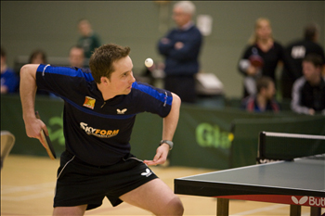
Ryan Jenkins (Wales) retained the Men’s Singles title and has now won five in a row. In a high quality match, Ryan was made to work hard for his 5 set victory against Lucjan Filimon of Rumania. Earlier, in the semi-finals, Ryan came through against his brother, and Welsh Number 4, Stephen Jenkins and Lucjan overcame, Scottish Number 2, Stewart Crawford.
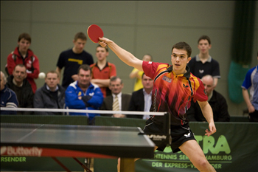
In a fantastic display of attacking table tennis Ryan made an excellent start with some very impressive third ball attacks and took the first two ends 11-8 and 13-11. This was no stroll in the park for Ryan however, as the last time he played Lucjan (World Ranked 311), in the Swedish Open, he lost. Lucjan hit back in the third, winning it 12-10 but Ryan then appeared to relax and played some wonderful flowing table tennis, taking the next two ends (12 and 4) and the title. The large crowd showed their appreciation in what was regarded as one of the best Men’s Finals for many years.
Ryan Jenkins won 11-8, 13-11, 10-12, 14-12, 11-4

The Ladies Final brought together Glasgow based Jenny Weiss and Amanda Mogey.
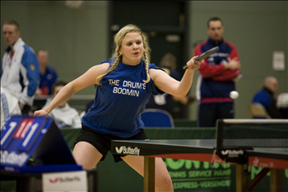
In the Semi Finals Jenny accounted for Scottish Number 1 Rebecca Russell, winning nine in the fifth end and Amanda came through against Fiona Dennet from Bristol. In the final, Jenny’s more consistent attack got the better of Amanda and she secured victory by four games to two and gave the West of Scotland their only title of the weekend.
Jenny Weiss won 11-5, 11-3, 11-5, 11-3

Notable results for West players included Paul Marshall and Josie Lawrence reaching the final of the Men’s Band 1 and Ladies Band 1 respectively. Paul narrowly lost out to David Atkins in one of the most entertaining and sporting finals of the day. On Sunday, Craig Hardie performed above his seeding in the U18 and U21 events reaching the final of both but lost out to Edinburgh’s Craig Howieson in both events. Scott Barton also performed well to reach the final of the Boys U13 but found Liam O’Shaughnessy of Dumfries too hot to handle in the final.
Event | Players |  |  | Result
Men’s Singles | Ryan Jenkins (Wales) | bt | Lucjan Filimon (Rumania) | 8,11,-10,12, 4
Ladies Singles | Jenny Weiss (WoS) | bt | Amanda Mogey | 10,-8,-6,6,5, 11
Men’s Band 1 | David Atkins (Edin) | bt | Paul Marshall (WoS) | 4, 9, -9, -2, 10
Ladies Band 1 | Julie Lawrence | bt | Josie Bruce (WoS) | 5, 8, 9
Men’s Doubles | R Jenkins / S Jenkins | bt | S Crawford / C Howieson | -4, 8, 5, 9
Ladies Doubles | R Russell / F Dennett | bt | A Mogey / C Nelson | 5, -8, -8, 6, 5
U21 (Men) | Craig Howieson | bt | Craig Hardie (WoS) | -12, 7, 8,11
U21 (Ladies) | Claire Nelson (Ulster) | bt | Natasha Milliken (WoS) | 6, 6, 4
U18 Boys | Craig Howieson | bt | Craig Hardie (WoS) | 3, -9, 7, 6
U18 Girls | Claire Nelson | bt | Fiona Dennett | 5, 9, 5
U15 Boys | Calum Main (Dumfries) | bt | Liam O'Shaughnessy | 9, -8, 7, 9
U15 Girls | Ashley Givan | bt | Anna Donohue | 10, 7, 5
U13 Boys | Liam O’Shaughnessy | bt | Scott Barton (WoS) | 2, 4, 4
U13 Girls | Ashley Givan (Ulster) | bt | Holly Porteous (Dumfries) | 11, 8, 7

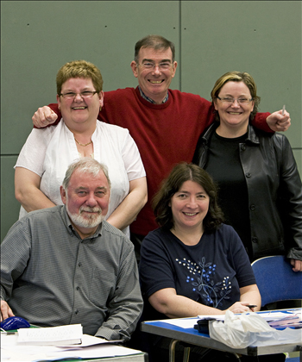
Thanks to the top table for all their hard work over the two days:
  - Charlie Flint
  - Tricia Whitaker
  - Ken Cadogan
  - Catherine &
  - Alison McBean
Thanks also to Terry McLernon, Phil McCallum of Drumchapel TTC and their willing band of helpers; Sarah Moffat, Peter Stewart, Peter Cameron and Hugh McLaughlin for their support. The West Open could not take place without you.

