 | Premier | P | W | L | F | A
1 | North Ayrshire A | 14 | 14 | 0 | 61 | 9
2 | Drum A | 14 | 12 | 2 | 56 | 14
3 | Drum B | 14 | 9 | 5 | 46 | 24
4 | Drum E | 14 | 8 | 6 | 32 | 38
5 | Drum C | 14 | 6 | 8 | 29 | 41
6 | Greenock | 14 | 4 | 10 | 25 | 45
7 | South Ayrshire A | 14 | 3 | 11 | 22 | 48
8 | Drum D | 14 | 0 | 14 | 9 | 61
 | Division 1 | P | W | L | F | A
1 | Knightswood A | 22 | 20 | 2 | 154 | 44
2 | South Ayrshire B | 22 | 14 | 8 | 120 | 78
3 | Nomads A | 22 | 16 | 6 | 114 | 84
4 | Drumchapel G | 22 | 15 | 7 | 113 | 85
5 | Kilwinning A | 22 | 12 | 10 | 104 | 94
6 | Drumchapel F | 22 | 13 | 9 | 103 | 95
7 | Carluke | 22 | 11 | 11 | 103 | 95
8 | Coatbridge | 22 | 12 | 10 | 95 | 103
9 | 44th Boys Brigade | 22 | 8 | 14 | 85 | 113
10 | Knightswood B | 22 | 4 | 18 | 73 | 125
11 | Garnethill | 22 | 4 | 18 | 65 | 133
12 | Mearns | 22 | 3 | 19 | 59 | 139
 | Division 2 | P | W | L | F | A
1 | Holyrood | 22 | 22 | 0 | 158 | 40
2 | Nomads B | 21 | 15 | 6 | 133 | 56
3 | Knightswood C | 22 | 18 | 4 | 130 | 68
4 | Maccabi A | 21 | 15 | 6 | 114 | 75
5 | Kilwinning B | 22 | 13 | 9 | 107 | 91
6 | Knightswood D | 22 | 11 | 11 | 95 | 103
7 | Brunswick A | 22 | 10 | 12 | 93 | 105
8 | Holy Cross HS | 22 | 7 | 15 | 81 | 117
9 | Castlemilk Eagles | 19 | 9 | 10 | 78 | 93
10 | North Ayrshire B | 21 | 5 | 16 | 69 | 120
11 | Maccabi B | 22 | 4 | 18 | 56 | 142
12 | Brunswick B | 22 | 0 | 22 | 47 | 151
Premier Division
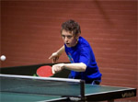
North Ayrshire secured the title for the third season running, proving once again to be the strongest team in the West. This result is even more impressive when their results for the last three years are examined – they haven’t lost a match. Their doubles performances match the quality of their singles play and proved crucial in some of their 3-2 wins. Craig Hardie was the best singles player of the season with 100% record. Drumchapel B also had a great run securing third place with two junior players, Calum Main and Daniel Swaitek both posting impressive averages.
Flying the flag for the vets we had Tam Lawlor, Callum Gerrard and Peter Cameron all performing to a good level and it’s good to see Peter (Über Vet) winning games rather than just giving everyone a hard game.

Division 1
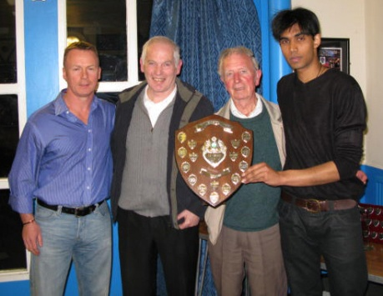
Knightswood A won the Division 1 title at a canter with Hasitha Samaraweera recording a 100% in the averages and ably backed by Neil Docherty and Ian Hay. Individually, Adam Gaffney 44th B.B. had a great season and Roy Claxton is still up there with the best of them. Players to look out for next season are Basel Razouk and Graeme Donnelly who improved consistently over the season.

At the other end of the table Mearns are relegated and Garnethill face a play-off with Nomads.

Knightswood A also picked up the Maxwell Wilson Cup beating Drumchapel F 5-1 in the quarter–final, followed by a matching score line in the semi against Mearns and then, to complete the league and cup double, South Ayrshire B in the final by a 5-2 margin.

Division 2
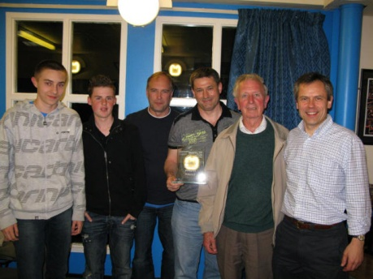
Holyrood were just too strong this season with a combination of seasoned performers and improving juniors. It was good to see their juniors Callum Renton and Ross Grant holding their own against a wide variety of styles and experience. Bill Conroy, in his first experience of competitive TT, also did well for Holyrood particularly in the second half of the league programme. Martin Oestmann (Knightswood C) topped the player averages and should do well if he moves up to the first division next season. Nomads deserved their second spot and still have a chance of playing in the first division if they win the play-off.

Brunswick B find themselves propping up the wrong end of the league, followed closely by Maccabi B. The junior team of North Ayrshire came next but I’m sure they are a safe bet to finish in the top half next season.

Holyrood matched Knightswood A by completing the double and secured the House of Harris Cup in fine style. They beat Knightswood C 5-2 in the quarter-final, Maccabi A 5-1 in the semi-final and Kilwinning B 5-0 in the final.

Carluke did well to win the Walter McNeil Handicap Cup and appeared to get stronger each round they played.

AGM Photos

Graham Crawford and Roll of Honour
Graham Crawford - Honorary Life Member
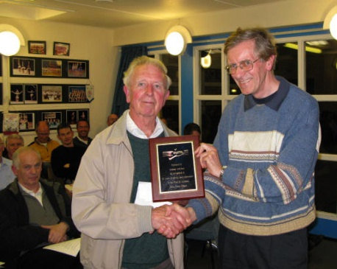
Liam Hughes, WoSTTL Secretary, and team-mate of Graham's, presented him with a plaque to recognise his Honorary Life Membership of the West of Scotland League.
Liam informed members that Graham has played for clubs which Liam never knew existed and some which even Graham has forgotten - a list which includes Hillington, Lenzie, Airdrie, Bishopbriggs and Brunswick. Graham has never been among the tournament high-fliers nor had major administrative positions in the League but, acting as a team secretary for tens of years and turning out for matches year-in, year-out, he represents that bedrock of committed players upon which the League’s continued existence depends.
Graham started his West of Scotland League career in 1960 and has played continuously since then which means he has just completed his 51st season. He also reaches another milestone this summer, his 80th birthday, but is already written in as one of Brunswick's confirmed team players for next season. Fantastic! Congratulations Graham.
Roll of Honour
Premier League
Champions | North Ayrshire
Top Player | Craig Hardie
Division 1
Champions | Knightswood A
Top Player | Hasitha Samaraweera
Players' Player | Basel Razouk & Duncan McKenzie
Maxwell Wilson Cup
Winners | Knightswood A
Runners -Up | South Ayrshire B
Division 2
Champions | Holyrood
Top Player | Martin Oestmann
Players' Player | Tamami Igarashi
House of Harris Cup
Winners | Holyrood
Runners -Up | Kilwinning B
Walter McNeil Cup
Winners | Carluke
Runners -Up | Mearns
Senior Player of the Year | Hasitha Samaraweera
Junior Player of the Year | Calum Main
Cadet Player of the Year | Scott Barton
Minor Player of the Year | Donna Gillon
Honorary Life Member | Graham Crawford (Brunswick)

Junior League

Division 1 | P | W | L | F | A
Drumchapel A | 7 | 7 | 0 | 31 | 4
Holyrood A | 7 | 6 | 1 | 30 | 5
North Ayr. A | 7 | 4 | 2 | 18 | 12
44th BB | 7 | 3 | 4 | 14 | 21
North Ayr. B | 7 | 3 | 3 | 14 | 16
East Kilbride | 7 | 3 | 4 | 13 | 22
Holyrood B | 7 | 1 | 6 | 8 | 27
Drumchapel B | 7 | 0 | 7 | 7 | 28

Division 2 | P | W | L | F | A
Drumchapel | 7 | 6 | 1 | 31 | 4
North Ayrshire | 7 | 5 | 2 | 24 | 11
East Kilbride B | 7 | 5 | 2 | 21 | 14
Knightswood | 7 | 5 | 2 | 20 | 15
East Kilbride A | 7 | 4 | 3 | 18 | 17
Holyrood | 7 | 1 | 6 | 13 | 22
44th BB | 7 | 2 | 5 | 11 | 24
South Ayrshire | 7 | 0 | 7 | 2 | 33

Division 3 | P | W | L | F | A
Drumchapel | 7 | 7 | 0 | 29 | 6
East Kilbride | 7 | 5 | 2 | 25 | 10
Knightswood A | 7 | 5 | 2 | 24 | 11
North Ayrshire | 7 | 5 | 2 | 24 | 11
44th BB | 7 | 2 | 5 | 13 | 22
Knightswood B | 7 | 1 | 6 | 12 | 23
278th BB | 7 | 3 | 4 | 11 | 24
South Ayrshire | 7 | 0 | 7 | 2 | 33

Junior League - Final Day
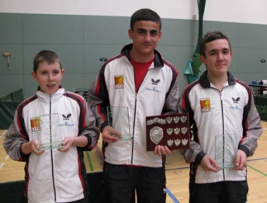
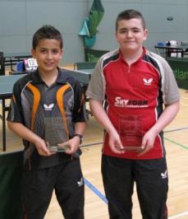
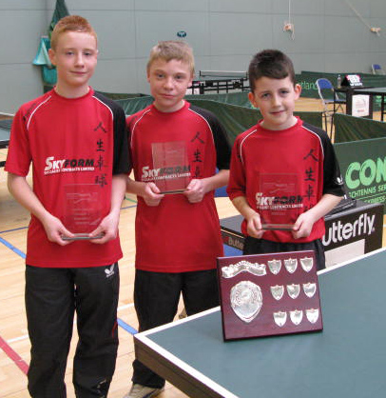
The Junior League reached its climax at the weekend and over the four sessions plenty of great Table Tennis was played. Division One produced a familiar situation with Drumchapel and Holyrood fighting it out for the top spot. Drumchapel ran out worthy winners but only just. They won the title by one point thanks to Bazel Razouk winning both his singles against Callum Renton and Philip Houston and Rory Boyd also beating Philip. Holyrood took some consolation from Callum Renton and Ross Grant sharing the Division’s top player award.
As already reported Drumchapel’s team of Yaser Razouk and Thomas Cairns won the Division 2 title with North Ayrshire taking second spot. Jordan McKinlay followed last year’s Division 3 leading player award with the Division 2 award this year – well done Jordan.
Division Three produced another close finish with Drumchapel requiring to beat Knightswood to be sure of the title. Greg Robertson, Calum McNair and Stephen McDonald of Drumchapel delivered what was required, a 4-1 over their close rivals. Congratulations to this young team. Greg Robertson and James Kennedy (North Ayrshire) shared the leading player title.

Thanks to Alex Hardie for organising the league fixtures and results, Malcolm Smith for number crunching the league tables and averages and Sinclair Houston and Greg Taylor (and the others who helped) for setting up and dismantling the hall.

Not sure if we will be able to use Holyrood next year as the Junior League venue as they are closing early (3:00pm) on Saturdays from 1 April. Watch this space!

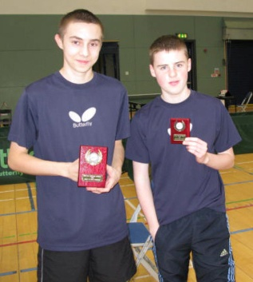 | 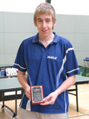 | 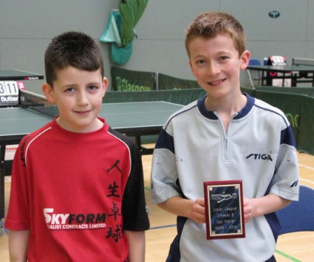

Six of the Best at the Inter League
Winning titles was the order of the day for the West of Scotland at the Scottish Inter League Championships which took place at Inverclyde, Largs on the 17 & 18 April.
The West teams won six titles out of a possible nine and also secured, for the second year in a row, the Stewart McGowan Trophy for the most successful League at the competition.
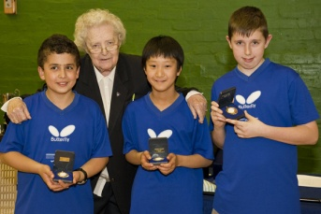
The following titles were won - Minor Girls, Minor Boys, Cadet Boys, Junior Boys, Ladies, and Veteran Men and we were also runners up in the Mens' and Minor Girls' events.
It was a first time win and in impressive style for the Minor Boys Team of Rory Boyd, Yaser Razouk and Justin Yang and in the Ladies event Maureen Moran and Tamami Igarashi won the title for the first time in 4 years.
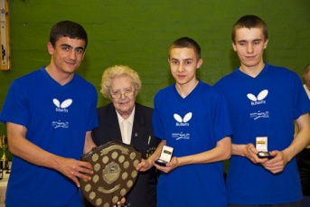
The Junior Boys Team - Daniel Swiatek, Basel Razouk and Callum Renton retained the title for the third time. The team was undefeated over the weekend with Basel winning all his games and Daniel and Callum dropping just one game each.
The Cadet Boys - Adam Gaffney, Connor Moran and Callum Quinn - secured the title by virtue of countback. They lost a close match to North Ayrshire but a victory over Edinburgh, whom they tied with for the title, proved to be crucial.
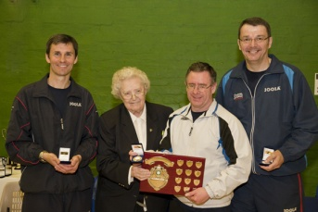
Another first time winner was the team of Callum Gerard, Malcolm Hutton and Roy Claxton who won the Veterans Championships. They beat a strong Aberdeen side 3-2 in the final thanks to a win apiece from the three players including Roy snatching victory from the jaws of defeat, he was 4-10 down and 2 sets down before securing the win.
The other West teams all performed well – the Minor Boys B team of Greg Robertson, Ross McCrae and Allan Woodhouse secured three wins, the Minor Girls B team of Nadia Doherty and Caitlan Cameron were second and the Cadet Boys B team secured a number of fine wins which suggests a bright future for these players.
Congratulations to all teams, players and thanks to all NPCs, parents and supporters and to Moira and Russell Elliott who organised the food on the Saturday night.
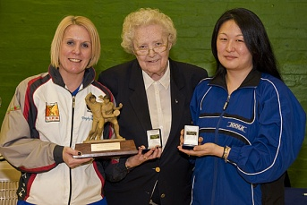 | 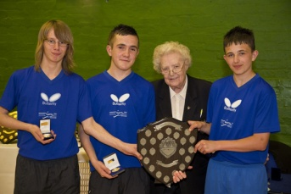 | 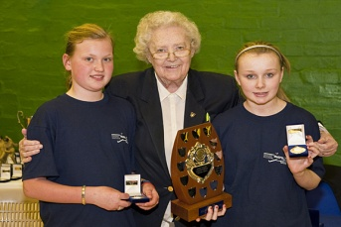
Inter League Gallery
Photos by courtesy of Studio Cee

West Schools Report
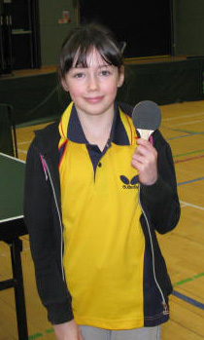
The West of Scotland Schools qualifying competition for the Scottish Secondary schools championships took place on Sunday, 31 January at Holyrood Sports Centre, Glasgow. With an entry of nearly 70, the best for many years, a full day of table tennis action was enjoyed by all players and spectators.
In addition to the Under 14, 16 and 18 age categories an under 12 competition for boys and girls along with an open doubles was added to the event.
Under 12 Girls
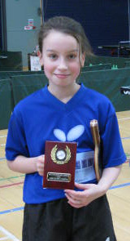
Nadia Doherty lived up to her top seed status and won all three of her matches. In her first match against Alisa Khalid she was taken to deuce in the first game but then moved into top gear and won the next two convincingly. Her next match was against one of the youngest competitors in the tournament, Emma Rhind. Nadia continued her good form but did drop the third end to Emma and then completed a hat trick of wins with a 3-0 victory over Hannah McCarron.
Under 12 Boys
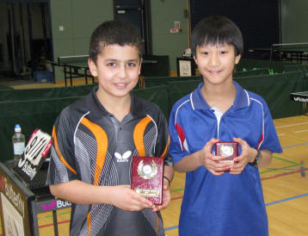
15 players competed in this event and in Group 1, top seed Yaser Razouk had two 3-0 wins over Zaid Khalid and Cameron McKenzie. His third and final match against Allan Woodhouse was much closer but he won through 11-6 in the fourth game. In Group 2, Greg Robertson had solid victories over Stewart Williams (3-1), followed by two 3-0 wins against Stewart Horsfall and Adam Stevenson. Justin Yang was in fine form in Group 3 with 3-0 wins over Matthew Hughes, Alistair Grant and Paul Gorman. In Group 4, Luc Fitzpatrick emerged in first place with 3-0 wins over Fraser Cowie and Conor Patrick.
In the top group Yaser Razouk secured the Under 12 title with 3-0 wins over Justin Yang and Luc Fitzpatrick and a close four end victory over Greg Robertson. Justin Yang was a deserving runner up after a five end thriller against Greg Robertson.
In the second group for runners up from the first round of matches Allan Woodhouse produced an impressive display winning all his matches 3-0, securing fifth spot overall.
Under 14 Boys
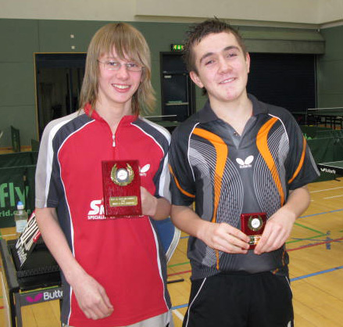
With an entry of 26 players the winner had to negotiate a first group then a group of three followed by a final. Adam Gaffney, Connor Moran, Rory Boyd, Jonathan Diack, Robert Matthew and Craig McGregor were all successful with this initial hurdle. Adam Gaffney, with wins against Rory Boyd (3-0) and Robert Matthew (3-0) manoeuvred his way into the final and Connor Moran had a slightly rockier ride to join him after a fifth end win against Craig McGregor and a 3-1 victory over Jonathan Diack.
In the final, Adam lost the first set against Connor but came back strongly winning the next three games 2, 9, 9 and the Under 14 title. Rory Boyd and Jonathan Diack secured second place in their groups and also qualify for the Scottish Schools Championships at the end of the February. Robert Mathew and Craig McGregor finished joint fifth, just missing out on a qualification place.
Under 16 Boys
Basel Razouk, top seed for this age group, duly took his place in the final group with 3-0 wins over Ross Grant, Joseph Wilson and Jordan Morris. Ross joined him with 3-0 victories over Joseph and Jordan. Meanwhile, Callum Renton was producing a similar performance in the second group with wins against Peter Liddell, Adam McMillan and fifth end win over Duncan Smith, who secured the runners up spot.
Basel, Callum, Duncan and Ross therefore all qualified for the Scottish Schools Finals but who would win the under 16 title?
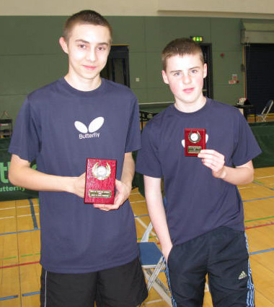
Basel got off to the worst start possible losing to Duncan by a margin of 3 games to 1, while Callum rattled out a 3-0 win over practice partner Ross. Callum then made his intentions very clear with an emphatic 3-0 win over Duncan; and then Ross stayed in the hunt with a four game victory over Duncan. Basel then came back into contention and got a point on the board beating Ross 11-8 in the fifth. Callum and Basel then served up a very entertaining final match, with the winner takes all.
Callum made the better start, taking the first two ends 11-9, 11-6. Basel seemed to then get his timing back in gear and restored parity, winning the next two ends 11-6, 11-8. Callum, however, was not to be denied and won the final end 11-9 to secure his first West schools title.
In the second group Adam McMillan came out on top to secure fifth place with wins over Peter Liddell (3-0), Jordan Morris (3-1) and Joseph Wilson (3-0).
Consolation
Ross McNulty made up for his early exit in the under 14 event by winning the consolation singles from Cameron McNair
Open Doubles
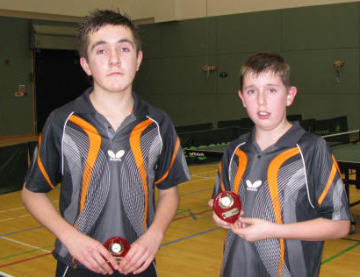
An Open Doubles, with 16 pairs, was played to finish off the day. Top seeds Callum Renton and Ross Grant progressed to the semi finals without trouble and then faced Johnny Diack and Jacob Aitchison. They dropped the first end but then ran out comfortable winners -11, 5, 7, 8. In the other half, second seeds Connor Moran and Rory Boyd manoeuvred through a demanding quarter final tie against brother and sister act Nadia and Sean Doherty, winning 11-7 in the fifth. Their semi final was more straightforward, securing a 3-0 win against Adam Gaffney and Ross McNulty.
In a very entertaining five game final Callum and Ross managed to go one better than last year and secured the title from Rory and Connor -7, 6, 7, -5, 8.
Qualifiers for Secondary Schools finals, Bell’s Sports Centre, Perth – 28 February, 2010
 | Under 14 | Under 16 | Under 18
Boys | Adam Gaffney | Callum Renton | Sean Doherty
 | Connor Moran | Ross Grant | Daniel Swiatek
 | Rory Boyd | Duncan Smith | Nathan Courtney
 | Jonathan Diack | Basel Razouk | Marcus Dick
Girls | Under 14 |  | Under 18
 | Donna Gillon |  | Emma Notarangelo
 | Lucy Elliot
 | Caitlan Cameron
 | Carla Rankin
West Open
The 2010 West of Scotland Open took place at Holyrood Sports Centre in Glasgow on 23rd & 24th January 2010. This year’s event attracted some of the best players from the United Kingdom and was generously supported by the Sports Council for Glasgow, Culture & Sport Glasgow, Skyform and Tees Sport.
Day 1
Men’s Singles
At the group stages, all 13 seeds safely made it through without too much trouble. In the last 32 Calum Main scored a good win over Richard Main in a five set match; also Daniel Swiatek recorded a fine win over Stewart Armitage.
In the last 16, Calum Main upset the seeding again by defeating number 5 seed Michael Marsden, in what was the best match of the round. Patrick Thomas survived a real challenge from Chris Main, coming through 3-1.
Quarter final stage
Ryan Jenkins got the better of the young pretender Calum Main, 3-0, Stewart Crawford survived a real challenge from Craig Hardie winning 11-8 in the fifth, Craig Howieson beat Stephen Jenkins 3-1 and Wang Zheng beat Patrick Thomas 3-0
Semi Final Stage
Ryan Jenkins was in commanding form against Wang Zheng and never allowing him to get into the match, winning 11-8, 11-5, 11-7.
Craig Howieson was in impressive form against Stewart Crawford in the other semi final winning the match 11-7, 11-4, 11-7 to reach the final of the West of Scotland Open for the first time.
Men’s Singles Final
The Men’s Singles final of the West of Scotland Open brought together the Welsh Tiger Ryan Jenkins and Edinburgh’s finest Craig Howieson, Scotland’s number 3 player. The final was best of 7 sets.
Despite a valiant effort by Craig, Ryan claimed his 6th Men's Open Title. The match was finally balanced at 2 sets all with Ryan and Craig treating the spectators to many fast exciting rallies. Ryan won the fifth end by the closest of margins and then got off to a 6-0 start in the seventh. Craig just couldn't come back from this, and Ryan took the match by 4 sets to 2.
Ryan Jenkins bt Craig Howieson 6-11, 12-10, 9-11, 11-8, 12-10, 11-4.
Ladies Singles
In the ladies competition 5 groups of ladies battled it out. In group 1 Naomi Owen took no prisoners to win group 1 with Melissa Wright taking second place. In Group 2, Elaine Forbes took number 2 seed Karina Lefevre (Eng) to the wire losing out 10-12 in the fifth set. Karina Won Group 2 with Elaine taking second place. In group 3 Gillian Edwards upset the seeding by beating Rebecca Russell to win the group and Rebecca took the runners up spot. Corinna Whitaker won group 4 and Roxanna Milne had to battle hard against Rhian Williams to finish runner up. Group 5 was won by Chloe Whyte (Eng) who was involved in a five set marathon match with Natasha Milliken, Natasha finished runner up.
At the knockout stages, Elaine Forbes continued her good form to beat Rebecca Russell 11-4, 7-11, 11-5, 11-5 and reach the quarter finals. Melissa Wright beat Natasha Milliken 11-8, 11-7, 11-9 to join her.
Quarter Finals
Naomi Owen (Wales) had a good match with Elaine Forbes winning 12-10, 11-5, 11-9. Karina Lefevre (Eng) had to work hard to beat Melissa Wright (Eng) 11-8, 1-11, 11-5, 11-7. Chloe Whyte (Eng) beat Corinna Whitaker 11-3, 11-4, 11-7 and Gillian Edwards beat Roxanna Milne 14-12, 11-4, 11-5.
Semi Finals
In the first semi final, Naomi Owen (Wales) beat Chloe Whyte (England) 12-10, 11-2, 11-6, 11-7 and was joined by Karina Lefevre (England) who beat Gillian Edwards 11-8, 11-8, 16-14.
Ladies Singles final
Naomi and Karina are both working towards representing Britain at the Olympic Games in London 2012 and are amongst the finest female players competing in Britain at the moment so the crowd was treated to a high quality final.
Naomi started off strongly winning the first two sets 11-6, 11-9, but Karina demonstrated her quality by winning the third and fourth sets 13-11 and 14-12. In the fifth set both players battled for every point with Naomi shading it 12-10. In the 6th set Karina was 10-7 up and looked to be taking it to a 7th deciding set only for Naomi to use all her experience winning the 6th set 14-12 to win the title for the first time. A fantastic match and a real treat for the West crowd.
Naomi Owen (Wales) bt Karina Lefevre (England) 11-6, 11-9, 11-13, 12-14, 12-10, 14-12
Results Summary

Men’s Singles | Ryan Jenkins | Craig Howieson | 4-2
Ladies Singles | Naomi Owen | Karina Lefevre | 4-2
Men’s Doubles | R. Jenkins/S. Jenkins | C. Howieson/S. Crawford | 3-0
Ladies Doubles | N. Owen/C. Whyte | N. Milliken/C. Whitaker | 3-0
Men’s Band 1 | Hasithia Samaraweera | Peter Shaw | 3-0
Ladies Band 1 | Stephanie McCallum | Lynda Flaws | 3-0

Day 2
The West Open continued on Sunday 23rd January with the younger age groups in action ranging from under 13 through to under 21.
Minor Boys (Under 13)
In group 1, Christopher Wheeler, the current British Primary Schools Champion, came out on top 1. It wasn’t all plain sailing for Chris however, with a close match against Jason Fleming (Perth), winning 3-1. In Group 2, Alexander Duff (Wales) emerged on top with Justin Yang (WoS) as runner up. In Group 3, Alastair Rennett prevailed from Rory Boyd (WoS) and in group 4 Yaser Razouk scored a good win against Josh Henderson to top the group with Josh in second spot.
Quarter Finals
Christopher Wheeler was in convincing form with a 3-0 win against Josh Henderson. Alastair Rennett won 3-0 against Justin Yang. Jason Fleming saw off Yaser Razouk 3-0 and Rory Boyd beat Alexander Duff 3-0.
Semi Finals
Christopher Wheeler saw off the challenge of Alasdair Rennett with a 3-1 win and Rory Boyd defeated Jason Fleming 3-0 to reach his first national final.
Final
The final of the minor boy’s event saw the current British Primary Schools Champion Christopher Wheeler up against one of the up and coming players from the West of Scotland Rory Boyd. The first two sets went to Christopher but Rory showed he is one to watch for the future winning the third set; Christopher then came back strongly to win the 4th and deciding set.
Christopher Wheeler beat Rory Boyd 11-7, 11-2, 8-11, 11-4
Minor Girls (Under 13)
In group 1, Lucy Elliott (WoS) won this group with wins against Nicole Wright, Jill Talyor and Bethany Payne. Nicole was runner up.
In group 2, Donna Gillon (WoS) was given a scare from Rachel Crawford, recovering from two sets down, to win the fifth set. Fiona Scott (Perth) was in good form and beat Donna to win the group.
Semi Finals
Lucy Elliott (WoS) won the first sets, with some great attacking table tennis, against Drumchapel team mate Donna Gillon. , Donna fought back to take the 3rd and 4th sets, but Lucy was not to be denied and took the 5th set to reach the final.
Fiona Scott took no chances against Nicole Wright winning 3-0
Final
The final saw Lucy Eliott, the current Scottish Primary Schools Champion, up against Fiona Scott, Scottish Primary Schools runner up.
In a rollercoaster final, Lucy got off to a good start winning the first set but Fiona came straight back to win the second. Lucy then secured the third, only for Fiona to restore parity by taking the fourth. The fifth set couldn’t have been closer and Fiona showed her true fighting spirit and shaded it 14-12.
Fiona Scott bt Lucy Elliott 8-11, 12-10, 11-4, 4-11, 14-12
Cadet Boys (Under 15)
Scott Barton won group 1 with wins against Andrew MacPherson, Paul Jarvie and Alasdair Rennett. Group 2 was won by Blair Fowler, who beat Chris Barclay, Greg Robertson and Rory Boyd. Christopher Wheeler won group 3 beating Yaser Razouk, James Kennedy and Connor Moran. Ying Jin won group 4 beating Matthew Patterson, Stuart Lewis and Calum McNair. Adam Gaffney won group 5 beating George Beattie, Jonny Diack and Alistair Scott. Garry Wright won group 6 beating Stephen McDonald, Sam Parry and Grant Lewis. Alex Wheeler won group 7 beating Duncan Smith, Jack Parry and Thomas Cairns.
Knockout stages
Adam Gaffney beat Stuart Lewis 3-0. Alex Wheeler beat Rory Boyd 3-0. Chris Wheeler beat Grant Lewis. Ying Jin beat Connor Moran 3-0. Alistair Scott beat Alasdair Rennett 3-1. Jack Parry beat Garry Wright 3-1.
Quarter Finals
Scott Barton beat Adam Gaffney 3-0. Chris Wheeler beat his older brother Alex 3-0. Ying Jin beat Alistair Scott 3-0 and Blair Fowler beat Jack Parry 3-0
Semi Finals
Scott Barton was impressive against Chris Wheeler, winning 3-0. Blair also beat Ying Jin 3-0 to reach the final.
Final
The final brought together the top two cadets in the country. Scott started off stronger winning the first two sets, but then dropped the third set. He then regained his composure to win the fourth and secure the match 3-1.
Scott Barton beat Blair Fowler 11-8, 11-8, 2-11, 11-6
Cadet Girls (Under 15)
Carys Webster (Wales) upset the seeding by beating Nadine Wright to win group 1. Lara Stirling won group 2 beating Rachel Crawford, Fiona Scott and Nicole Wright. Jennifer Hart also upset the seeding by beating Donna Gillon. Renee Ho won group 4 beating Lucy Elliott and Alix Edwards.
Quarter Finals
Carys Webster beat Lucy Elliott 3-0, Jennifer Hart beat Rachel Crawford 3-0, Renee Ho beat Nadine Wright 3-1 and Lara Stirling beat Donna Gillon 3-1.
Semi Finals
Carys Webster beat Jennifer Hart 3-0 and Lara Stirling beat Renee Ho 3-1.
Final
The final brought together Carys Webster (Wales) versus Lara Stirling. Carys got off to the better start winning the first two sets and looked to be in control, only for Lara to stage a fightback winning the next 3 sets to take the title.
Lara Stirling beat Carys Webster 4-11, 6-11, 11-9, 12-10, 13-11
Junior Boys (Under 18)
Sean Doherty won group 1 beating David Marsh, Michael McGuire and Adam Gaffney. Calum Main won group 2 beating James Kennedy and Thomas Grant. Scott Barton beat Jamie Skelton and Garry Wright to win group 3. Jordan McGinley won group 4 beating Ross Grant and Jonathan Diack. Blair Fowler upset the seeding beating Nathan Courtney to win group 5, Blair also beat Alex Wheeler and Grant Lewis. Stephen Fowler won group 6 beating Duncan Smith and Grant Lewis. Colin Dalgleish won group 7 beating Calum McNair, Stephen McDonald and Andrew MacPherson. Neil McDonald won group 8 beating Thomas Cairns, Robbie Fairley and Callum Renton. Ying Jin won group 9 beating Chris Barclay and Connor Moran.
Preliminary Matches
Duncan Smith beat James Kennedy 3-0. Nathan Courtney beat Garry Wright 3-1.
Knock out stages
Sean Doherty beat Duncan Smith 3-0, Colin Dalgleish beat Connor Moran 3-1, Blair Fowler beat Ross Grant 3-0, Scott Barton beat Robbie Fairley 3-1, Adam Gaffney beat Jordan McGinley 3-0, Steven Fowler beat Ying Jin 3-1, Neil McDonald beat Andrew McPherson 3-0, Calum Main beat Nathan Courtney 3-2.
Quarter Finals
Sean Doherty continued his impressive form beating Colin Dalgleish 3-0, Scott Barton beat Blair Fowler 3-1, Steven Fowler beat Adam Gaffney 3-0, Calum Main beat Neil McDonald 3-0.
Semi Finals.
Sean Doherty beat Scott Barton 3-1 and Falkirk’s Stephen Fowler caused an upset beating Calum Main 3-2.
Final
The final brought together reigning Scottish Junior Champion Sean Doherty against Stephen Fowler. Stephen started off very well winning the first set, Sean then won the second and although Stephen had his chances in a close third set, losing 10-12, Sean sealed the title in the fourth with an impressive range of shots.
Sean Doherty beat Stephen Fowler 3-11, 11-6, 12-10, 11-6.
Junior Girls (Under 18)
Karina Lefevre won group 1 beating Bethany Ross, Jillian Hyslop and Renee Ho. Chloe Whyte won group 2 beating Lynda Flaws and Nadine Wright. Melissa Wright beat Rhian Williams, Lara Stirling and Cira Hayes to win group 3. Natasha Milliken won group 4 beating Alice Williams, Kirsten Atkinson and Jennifer Hart.
Quarter Finals
Karina Lefefevre beat Lynda Flaws 3-0, Melissa Wright beat Alice Williams, Natasha Milliken beat Renee Ho and Chloe Whyte beat Lara Stirling 3-0.
Semi Finals
Melissa Wright beat Karina Levfevre 3-2. Melissa won the first two sets 11-9, 11-9, but Karina came back strongly to win the third set 11-4 but Melissa was not to be denied and won the 4th set 11-9 to reach the final. Chloe Whyte beat Natasha Milliken 3-0 to reach the final.
Final
Melissa again won the first two sets 11-8 and 11-5, but Chloe came back to win the 3rd set 11-7. Melissa then secured the 4th set, 12-10 to take the title.
Melissa Wright beat Chloe Whyte 11-8, 11-5, 7-11, 12-10
Under 21 Event
With the withdrawal of number 1 seed Patrick Thomas, Stephanie McCallum came through group 1 as winner beating Jillian Hyslop and Jordan McGinley. Sean Doherty won group 2 beating Sadie Edwards, Greg McLure and Danny Leister. Calum Main beat Jamie Skelton, Rhian Williams and Colin Dalgleish to win group 3. Ceri James withdrew from group 4 leaving Neil McDonald to win it with wins against Lynda Flaws and Andrew Grant. Karina Lefevre beat Daniel Swiatek, Steven Stewart and Robbie Fairley to win group 5. Nathan Courtney beat Melissa Wright and Ross Grant to win group 6. Chloe Whyte beat Steven Fowler, Graeme Donnelly and Bethany Ross to win group 7.
Knockout Stages
Stephen Fowler beat Colin Dalgleish 3-0, Neil McDonald beat Jordan McGinley 3-0, Daniel Swiatek beat Nathan Courtney 3-1, Karina Lefevre beat Melissa Wright 3-2, Chloe Whyte beat Sadie Edwards 3-0, Lynda Flaws beat Stephanie McCallum 3-2.
Quarter Finals
Sean Doherty beat Stephen Fowler 3-0, Daniel Swiatek beat Neil McDonald 3-0, Karina Lefevre beat Chloe Whyte 3-1, Calum Main beat Lynda Flaws 3-0.
Semi Finals
Sean Doherty beat Daniel Swiatek 3-2 and Calum Main beat Karina Lefevre 3-0.
Final
Sean started of strongly to win the first set, but Calum replied immediately to win the 2nd and 3rd sets. Sean then won the fourth set but then allowed Calum a good lead in the decider. Sean rose to the challenge and showed great fighting spirit to secure his second title of the day and won the decider 11-9.
Sean Doherty beat Calum Main 11-8, 9-11, 9-11, 11-5, 11-9
Results Summary
Minor Boys | Christopher Wheeler | Rory Boyd | 3-1
Minor Girls | Fiona Scott | Lucy Elliott | 3-2
Cadet Boys | Scott Barton | Blair Fowler | 3-1
Cadet Girls | Lara Stirling | Carys Webster | 3-2
Junior Boys | Sean Doherty | Stephen Fowler | 3-1
Junior Girls | Melissa Wright | Chloe Whyte | 3-1
Under 21 | Sean Doherty | Calum Main | 3-2

