2010 – 2011 League Roundup
Division 1
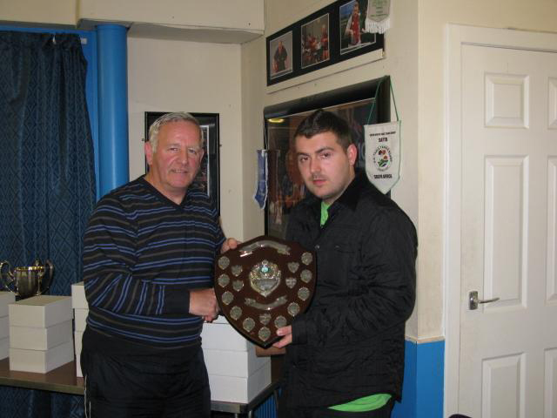
Division 1 was a combination of clubs from last year’s Premier league and the first division and it meant that some of the teams were outclassed by ex-Premier league players. However, a close battle at the top developed but when Knightswood A lost their star performer, Hasitha Samaraweera, they couldn’t match the consistency of Drumchapel A who won the title by just 3 points. Kilwinning A secured the third spot with consistent performances from all their players and Roy Claxton picked up the top player award with an impressive 86% average. There was an even closer battle at the other end of the division with final places undecided until the last match of the season. Coatbridge lost out in the relegation struggle and are relegated but Carluke retained their Division 1 status in the play-off match, producing a convincing 5-2 win against Division 2 runners up Knightswood B. George Flannigan’s win, 12-10 in the 5th, over Martin Oestmann in the first match proved to be crucial and set them up for their win.
Division 2
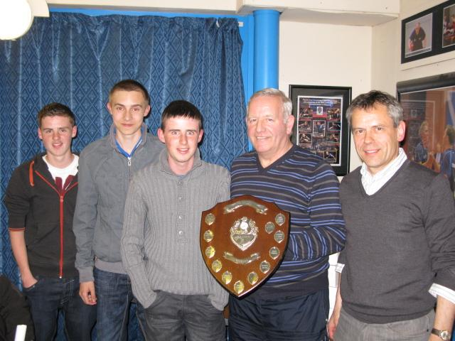
Glasgow South A with a combination of experience and youth were too strong for Knightswood B and won the title by 5 points. Callum Renton, Andy Grant and Ross Grant (Glasgow South) all had healthy averages and will now get a chance to test themselves at a higher level next season. Martin Oestmann produced another solid performance for second placed Kightswood B and was ably supported by Bill Davidson and Brian Irvine, who is enjoying his return to table tennis after a long break. Sinclair Houston (Glasgow South) just beat Luigi Caponi (Kilwinning) to the top player award. Maccabi A ended up at the wrong end of the league and are relegated and are joined by Brunswick A who lost their play-off match to North Ayrshire 5-3
Division 3
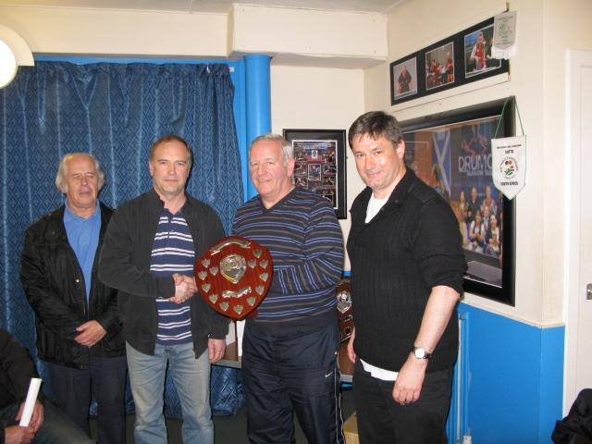
Division 3 was the hardest fought of the three divisions with three teams – Glasgow South B, North Ayrshire and Holy Cross High School - fighting it out for the title. Glasgow South B just edged home to victory by three points. Solid performances from Iain Rhind (leading player with 90%) and well supported by Bill Conroy on 88% provided the required consistency to stay ahead of North Ayrshire. However, with their subsequent win in the play-off, against Brunswick A, the Ayrshire outfit are one to watch in the future. Their team of four are all a good standard and will continue to improve. It was also good to see the young players of East Kilbride and Glasgow South C improve as the season progressed. They won a few games and this should give them a lift and something to work on for next season.
>> AGM Photos
Roll of Honour
 | Division 1 | Maxwell Wilson Cup
 | Drumchapel A | Knightswood A
 | Top Player | Players' Player
 | Roy Claxton | Natasha Miliken
 | Division 2 | House of Harris Cup
 | Glasgow South A | Knightswood B
 | Top Player | Players' Player
 | Sinclair Houston | Duncan McKenzie
 | Division 3 | Peter Coia Cup
 | Glasgow South B | North Ayshire
 | Top Player | Players' Player
 | Iain Rhind | Michael Schoenhofen &
 |  | Andrew McPherson
 | Walter McNeil Cup
 | Carluke
 | Senior Player of the Year | Junior Player of the Year
 | Natasha Milikin | Scott Barton
 | Cadet Player of the Year | Minor Player of the Year
 | Adam Gaffney | Lucy Elliot

Cup Finals
The Division 2 and 3 cup finals took place at Drumchapel High School on Thursday 19 April. Both finals produced a similar line up with Division 2 and 3 league winners Glasgow South A and Glasgow South B taking on league runners up Knightswood B and North Ayrshire
Division 2 - House of Harris Cup
Knightswood B 5-3 Glasgow South A
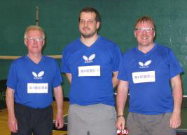
Glasgow South A got off to a bright start with Calum Renton securing a 3-0 win over Brian Irvine. The first two ends were close but by the third end Calum had worked out the tactics to overcome Brian’s combi bat puzzle. Andy Grant then consolidated the early lead for Glasgow South with an impressive 3-1 win over Bill Davidson. Andy didn’t allow Bill to settle applying a good third ball attack strategy. Glasgow South’s league and cup double party plans then began to come unstuck when Martin Oestmann scored a fine win over Sinclair Houston. He never allowed Sinclair to settle into his usual topspin game and scored a number of telling forehand winners wide to Sinclair’s forehand to secure a 3-1 success. Bill Davidson then restored parity for Knightswood winning 3-1 against Calum Renton. Bill combined well with Martin to take the first doubles 3-0 against Sinclair and Andy and then Martin consolidated Knightswood’s lead with another fine display against Andy, winning 3-0. Sinclair pulled one back for Glasgow South beating Brian Irvine 3-1 but Brian and Martin produced a fine doubles win against Andy and Calum by a margin of 3-0 and secured the cup win by 5 games to 3.

Man of the match was Martin Oestmann, he played really well winning his two singles and two doubles matches.

Division 3 Cup

North Ayrshire 5-3 Glasgow South B
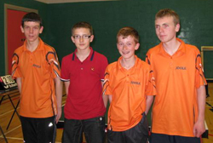
James Kennedy got North Ayrshire into an early lead with a fine 3-0 win over Kevin MacGregor. Glasgow South B then looked to the experience of Iain Rhind to get back on level terms but Andrew McPherson had other ideas and chalked up a 3-1 win with an impressive display of forehand attacking. Jamie Skelton then added to North Ayrshire’s lead with a close 3-2 win over Bill Conroy and Andrew McPherson added to Glasgow South’s woes with a solid 3-1 victory over Kevin. Iain Rhind and Bill Conroy combined well in the first of the doubles and, with a winning margin of 3-1, got Glasgow South off the blocks. Match score 4-1 to the young Ayrshire team. Glasgow South’s fight back continued with wins for Iain Rhind over Jamie Skelton (3-0) and for Bill Conroy over James Kennedy (3-1). Next up the second doubles and this proved to be decisive with the North Ayrshire combination of Andrew McPherson and Jamie Skelton, after some closely contested ends, securing the cup with a 3-1 win.
Man of the match was Andrew McPherson with two wins in the singles and a cup winning victory in the second doubles.

The Division 1 cup was won by Knightswood A with a walk-over in the final against Nomads A.

Junior League
The Junior League reached its climax on Sunday 20th March. 65 players took part over the four sessions and plenty of quality table tennis was played.
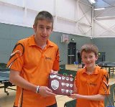
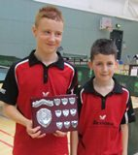
North Ayrshire secured the Division One title in style with a six point margin and winning all their matches. Jordan McKinlay followed last year’s Division 2 leading player award with the Division 1 award this year – well done Jordan. His North Ayrshire team mate, James Kennedy finished second in the averages. Drumchapel A and B could not be separated and shared second place. In their match with North Ayr, Drumchapel A lost narrowly but dropped points in other matches.
Division 2
Greg Robertson, Calum McNair and Stephen Grimes of Drumchapel won Division two by an impressive 10 points and for the second year running Greg Robertson picked up a leading player award. Holyrood just beat East Kilbride by a single point to secure second place.

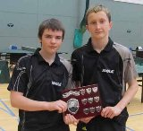
Division Three produced the closest finish with Stewarton requiring two 5-0 wins on the final day and Holyrood to lose their final match. This was in fact what was served up and Stewarton won the title by a single point from Holyrood. Congratulations to Stewarton’s Ryan Gardiner, Ryan Pitt and Michael Miller. Holyrood took some consolation in Joe Wilson winning the league averages.
Thanks to Alex Hardie for organising the fixtures and results, Iain Rhind for number crunching the league tables and averages and to everyone who helped set up the hall.

West Schools Report
The West of Scotland Schools Championships took place at Drumchapel High School on Saturday 6th February 2011. This is the first step towards qualifying for the Scottish Schools Finals (Bells Sports Centre, Perth, Sunday 27th February)and in turn the Senior Schools International being held in June.
Players from 24 different schools, colleges and universities participated in the event.
Under 12 Boys (16 players)
Group 1 Yaser Razouk beat Matthew Hughes, Dhruv Shah and Allan Woodhouse.
Group 2 Greg Robertson beat Onkar Gulati, Shreenil Vani and Conor Doherty.
Group 3 Stewart Horsfall, beat Fraser Cowle, Scott Wilson and Mark Grant.
Group 4 Alistair Grant, beat Ewan MacKenzie, Lewis Batting, and James Woods.
In the top group Yaser Razouk was crowned Champion, beating Greg Robertson 3-2 (11-8, 9-11, 11-4, 6-11, 11-4), Alistair Grant 3-0 (11-5, 11-4, 11-1) and Stewart Horsfall 3-0 (12-10, 11-5, 11-9).
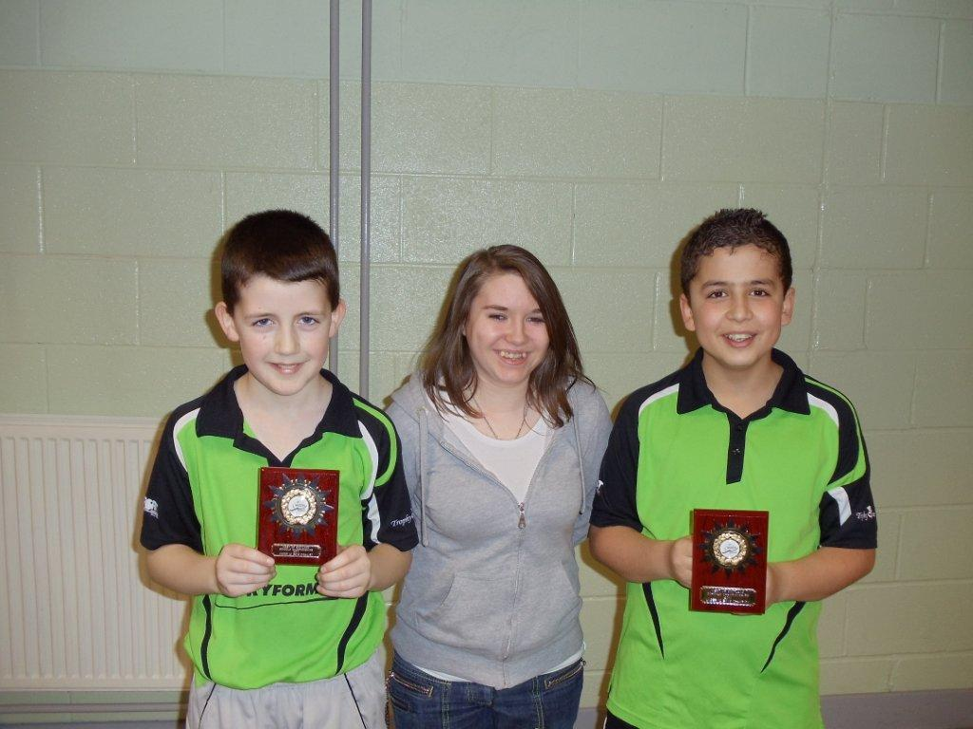
Final placing were:
1. Yaser Razouk (Killermont Primary School)
2. Greg Robertson (Drumchapel High School)
3. Stewart Horsfall (Gavinsburn Primary School)
4. Alistair Grant (Stonelaw High School)
Battling for positions 5-8 saw Conor Doherty won this group beating Fraser Cowle 3-0 (12-10, 14-12, 11-5) and James Woods 3-2 (8-11, 6-11, 11-9, 11-6, 16-14). Allan Woodhouse withdrew due to another commitment in the afternoon.
The final placing were:
5. Conor Doherty (Lady of Lorretto)
6. James Woods (Stonelaw High School)
7. Fraser Cowle (Cardonald Primary School)
8. Allan Woodhouse (Halferke Primary School)
In positions 9-12, Shreenil Vani came out on top beating Dhruv Shah 3-1 (8-11, 11-3, 11-8, 11-5), Scott Wilson 11-7, 11-7, 11-6) and Lewis Botting (6-11, 11-9, 11-8, 11-0).
Final placings were:
9. Shreenil Vani (Glasgow Academy)
10.Dhruv Shah (Glasgow Academy
11.Scott Wilson (Cardonald Primary)
12.Lewis Botting (Cardonald Primary)
In positions 13-16, Mark Grant beat Onkar Gulati 3-0 (13-11, 13-11, 11-7), Matthew Hughes 3-2 (10-12, 11-7, 11-7, 7-11, 11-5) and Ewan MacKenzie 3-0 (11-6, 11-6, 11-9).
Final placing were:
13.Mark Grant (Bankhead Primary)
14.Onkar Gulati (Glasgow High School)
15.Matthew Hughes (Cardonald Primary)
16.Ewan MacKenzie (Cardonald Primary)
Under 12 Girls (5 players)
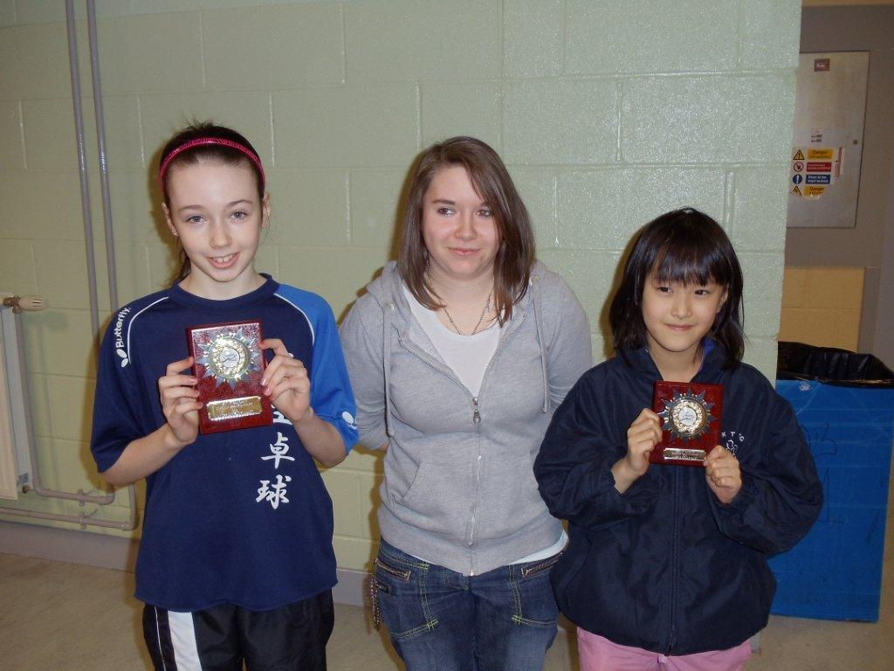
Congratulations to Emma Rhind on winning this event. Emma beat Khanak Gulati 3-0 (11-4, 11-1, 11-2), Serena Iheaguaram 3-0 (11-2, 11-0, 11-0), Claire Rankin 3-0 (11-1, 11-1, 11-2) and Jenny Yang 3-0 (11-3, 11-7, 11-6). The final placings were:
1. Emma Rhind (Halfmerke Primary School)
2. Jenny Yang (Carolside Primary School)
3. Claire Rankin (Holy Cross Primary School)
4. Khanak Gulati (Bankhead Primary School)
5. Serena Iheaguaram (Bakhead Primary School)
Under 14 Girls (6 players)
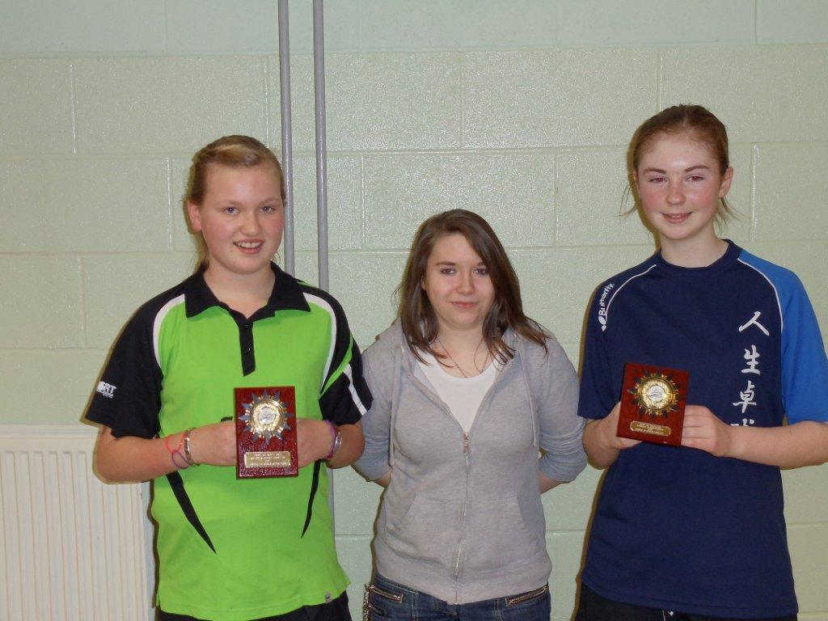
Congratulations to Lucy Elliott on adding another title to a very successful season. Lucy beat Caitlin Cameron 3-0 (11-6, 11-7, 11-8), Carla Rankin 3-0 (11-2, 11-1, 11-5), Hannah McCarron 3-0 (11-1, 11-2, 11-3)and Nadia Doherty 3-1 (6-11, 11-7, 11-6, 11-6).
The final placings were:
1. Lucy Elliott (Hermitage Academy)
2. Caitlin Cameron (Jordanhill Secondary)
3. Nadia Doherty (Scotstoun Primary)
4. Carla Rankin (Holy Cross High School)
5. Courtney Hamilton (Camstradden Primary School)
6. Hannah McCarron (Camstradden Primary School)
The top 4 in this age category have now qualified for the Scottish Schools Finals.
Under 14 Boys (5 players)
Congratulations to Justin Yang on winning the under 14 boys’ title. Justin beat Stewart Williams 3-0 (11-3, 14-12, 11-6), Yash Singh 3-0 (11-4, 11-4, 11-2), Cameron MacKenzie 3-0 (11-2, 11-4, 11-2), Greg Brown (11-2, 11-3, 11-7). The final placing were:
1. Justin Yang (Williamwood High School)
2. Stewart Williams (Rosshall Academy)
3. Greg Brown (Stonelaw High School)
4. Yash Singh (High School of Glasgow)
5. Cameron MacKenzie (Rosshall Academy)
The top 4 in this age category have now qualified for the Scottish Schools Finals.
Under 16 Boys (15 players)
Group 1 won by Stephen Grimes, who beat Jacob Aitchison, Christopher Keane, Michael Whitelaw, Euan McLaughlin.
Group 2 won by Duncan Smith, who beat Thomas Cairns, Daniel Stephen, Joe Wilson and Callum Quinn.
Group 3 won by Connor Moran, who beat Calum McNair, Greg Smith, Cameron Hussain and Jonathan Diack.
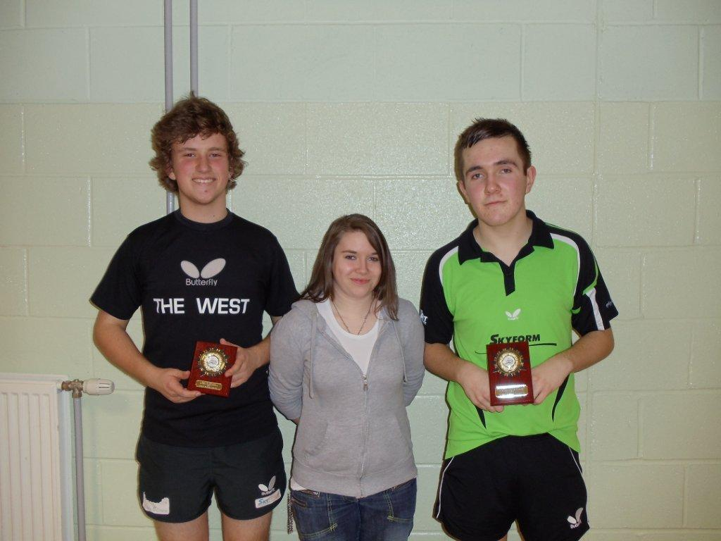
Competing for places 1-6 saw Connor Moran win this event, beating Duncan Smith 3-2 (11-6, 7-11, 9-11, 11-6, 11-9), Thomas Cairns 3-0 (11-9, 11-9, 11-9), Jacob Aitshison 3-0 (11-7, 11-7, 11-7), Stephen Grimes 3-0 (11-9, 11-2, 11-5) and Jonathan Diack w/o. The final placing were:
1. Connor Moran (Boclair Academy)
2. Duncan Smith(Boclair Academy)
3. Thomas Cairns (St. Peter of the Apostles)
4. Stephen Grimes (St. Peter of the Apostles)
5. Jacob Aitchison (not known)
6. Jonathan Diack (not known)
The top 4 in this age category have now qualified for the Scottish Schools Finals.
For positions 7-10, Calum McNair beat Joe Wilson 3-1 (5-11, 11-6, 15-13, 11-7), Christopher Keane 3-2 (8-11, 11-4, 14-12, 9-11, 11-6), Daniel Stephen 3-0 (11-2, 11-3, 11-6). Final positions were:
7. Calum McNair (Boclair Academy) 8. Joe Wilson (Taylor High School)
9. Christopher Keane (Stonelaw High School) 10. Daniel Stephen (Boclair Academy)
For positions 11-14, Cameron Hussain topped the goup with wins over Callum Quinn 3-2 (11-7, 11-9, 9-11, 7-11, 11-5), Greg Smith (w/o), Michael Whitelaw 3-0 (11-4, 11-8, 11-9).
Final positions were:
10.Cameron Hussain (Stonelaw High School)
11.Callum Quinn (unknown)
12.Michael Whitelaw (Rosshall Academy)
13.Greg Smith (Rosshall Academy)
Under 18 Boys
4 players automatically qualified:
Callum Renton (Stonelaw High) Ross Grant (Langside College)
Scott Barton (Knightswood Secondary) Stephen Fowler (Glasgow University)
Open Doubles (20 players)
In the preliminary rounds, Cameron Hussain/Chris Keane beat Dhruv Shah/Shreenil Vani 3-0 (11-6, 11-2, 13-11). Alistair Grant/James Woods beat Courtney Hamilton/Hannah McCarron 3-1 (9-11, 11-3, 11-6, 12-10).
In the quarter finals, Lucy Elliott/Connor Moran beat Stewart Horsfall/Conor Docherty 3-0 (11-7, 11-5, 11-9). Stephen Grimes/Calum McNair beat Joe Wilson/Emma Rhind 3-0 (11-3, 11-8, 11-6). Jacob Aitchison/Jonathan Diack beat Nadia Doherty/Caitlin Cameron 3-1 (11-3, 11-5, 13-11, 11-7). Yaser Razouk/Greg Robertson beat Alistair Grant/James Woods 3-0 (11-3, 11-4, 11-5).
In the semi finals, Stephen Grimes/Calum McNair beat Jacob Aitchison/Jonathan Diack 3-0 (11-8, 11-5, 11-3). In the other semi final Greg Robertson/Yaser Razouk caused a upset beating Lucy Elliott/Connor Moran 3-2 (6-11, 11-9, 11-8, 6-11, 13-11).
In the final, Greg Robertson/Yaser Razouk continued their good for to win the event, beating Stephen Grimes/Calum McNair in a five set thriller, eventually winning 3-2 (12-14, 11-7, 11-6, 9-11, 11-9).
Thanks to Stephanie McCallum, Moira Elliott, Catherine O’Neill and Terry McLernon for their sterling work in running this event.
Good luck to all the players who will represent the West of Scotland Schools at the Scottish Schools Finals - Bells Sports Centre, Perth - Sunday 27th February 2011.
West Open Results
Ryan Jenkins (Wales) won his 7th Men’s title at the West Open beating Scotland’s Craig Howieson in the final. The Women's title also went to Wales, with Naomi Owen retaining her title, beating Charlotte Cairey (Wales) in the final.
Scottish players, however, dominated the Junior events with Scott Barton taking both the under 21 and under 18 events, Blair Fowler the under 15, Chris Wheeler the under 13, and Lucy Elliot the under 13 girls.
 | West of Scotland Open 2011 - Results
 | Men’s Singles Champion – Ryan Jenkins | R/Up – Craig Howieson
 | Ladies Singles Champion – Naomi Owen | R/Up – Charlotte Cairey
 | Men’s Doubles Champions – R. Jenkins/S. Jenkins | R/Up – S. Crawford/C. Howieson
 | Ladies Doubles Champions – C. Thomas/A. Phillips | R/ Up – C. Carey/M. Phillips
 | Veterans Singles Champion – Willie Mabon | R/ Up – Gerry Campbell
 | Men’s Band 1 Champion – Chris Main | R/ Up – Richard Main
 | Men’s Band 2 Champion – Blair Fowler | R/ Up – Gordon Muir
 | Ladies Band 1 Champion – Charlotte Cairey | R/ Up – Chloe Thomas
 | Hardbat Champion – Terry McLernon jnr | R/ Up – Charlie Ellis
 | Disability Singles Champion – John Whitelaw | R/ Up – Kevin McCormack
 | Under 21 Singles Champion – Scott Barton | R/ Up – Ashley Robinson
 | Under18 Boys Champion – Scott Barton | R/ Up – Ashley Robinson
 | Under 18 Girls Champion – Chloe Thomas | R/ Up – Charlotte Cairey
 | Under 15 Boys Champion – Blair Fowler | R/ Up – Conor Edwards
 | Under 15 Girls Champion – Charlotte Cairey | R/Up – Lucy Elliott
 | Under 13 Boys Champion – Chris Wheeler | R/Up – John Hannah
 | Under 13 Girls Champion – Lucy Elliott | R/ Up – Rachel Crawford

