Summary Season 2011-12
Division 1
 |  | P | W | L | F | A
1 | Knightswood A | 19 | 16 | 3 | 135 | 36
2 | Drumchapel A | 19 | 17 | 2 | 120 | 51
3 | Glasgow South A | 19 | 11 | 8 | 92 | 79
4 | Drumchapel B | 19 | 10 | 9 | 85 | 86
5 | Nomads A | 19 | 9 | 10 | 91 | 80
6 | Kilwinning A | 19 | 9 | 10 | 79 | 92
7 | 44th BB | 19 | 6 | 13 | 66 | 105
8 | South Ayrshire | 19 | 4 | 15 | 53 | 118
9 | Carluke | 16 | 2 | 14 | 35 | 109
Division 2
 |  | P | W | L | F | A
1 | North Ayrshire A | 20 | 19 | 1 | 131 | 49
2 | Knightswood B | 20 | 16 | 4 | 126 | 54
3 | Coatbridge | 20 | 12 | 8 | 101 | 79
4 | Nomads B | 20 | 11 | 9 | 87 | 93
5 | Glasgow South B | 20 | 7 | 13 | 81 | 99
6 | Mearns | 19 | 7 | 12 | 81 | 90
7 | Garnethill | 19 | 8 | 11 | 78 | 93
8 | Knightswood C | 19 | 6 | 13 | 66 | 105
9 | Brunswick A | 19 | 2 | 17 | 41 | 130
Division 3
 |  | P | W | L | F | A
1 | Drumchapel C | 19 | 19 | 0 | 153 | 18
2 | Holy Cross | 19 | 13 | 6 | 100 | 71
3 | Maccabi A | 19 | 13 | 6 | 99 | 72
4 | North Ayrshire B | 19 | 11 | 8 | 90 | 81
5 | Brunswick B | 20 | 7 | 13 | 87 | 93
6 | Kilwinning B | 20 | 10 | 10 | 82 | 98
7 | Maccabi B | 20 | 6 | 14 | 67 | 113
8 | Knightswood D | 20 | 7 | 13 | 65 | 115
9 | Glasgow South C | 20 | 2 | 18 | 50 | 130

Division 1
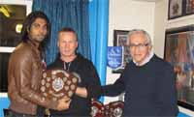
This season Kinightswood A comfortably won the 1st Division. Hasitha Samaraweera was unbeaten and topped the averages by winning 46 games. He was ably supported by Calum Gerrard, Neil Docherty and Simon Jeon also played a few games.
Drumchapel A opted for a younger element to their team. They should be much stronger next year because of the invaluable experience they have gained throughout the season at this level. The rest of the teams were closer to each other in their standard of play and there were some very good matches throughout the season.
Division 2
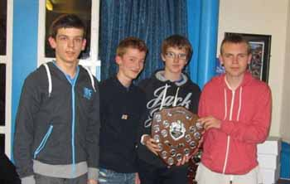
The 2nd Division produced a great battle this season between North Ayrshire 'A' and Knightswood B. North Ayrshire, winning on the last day of the season, had a pool of four players - Andrew McPherson, James Kennedy, Jamie Skelton and Chris Barclay, rotated every week, making this a great team effort. I feel this team will be a great addition to the first division.
Knighswood B, with Ian Hay topping the averages, are obviously strong enough to join them. We might see them in the 1st Division either through a play-off or restructuring of the league. As in the first division, the standard has been very competitive indeed. There were many close encounters throughout the season and made it very interesting when results arrived.
Division 3
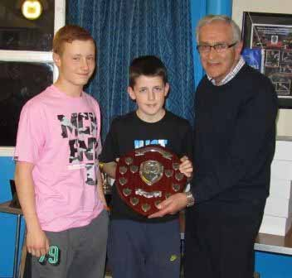
Drumchapel C had a strong pool of youngsters including Thomas Cairns (100% in averages) Steven Grimes, Yaser Razouk, Greg Robertson and Calum McNair, all played big parts in their title win. Holy Cross did well to hold on to 2nd place and Maccabi A were a close third.
There are quite a few young players in this division - Jordan McGinlay and Gill Taylor (North Ayrshire), Caitlin Cameron, Nadia Docherty (Knightswood) and Carla Rankin (Glasgow South) are a few of the promising names to look out for in the future.

AGM Gallery>>

Cup Competitions
Division 1 Maxwell Wilson Cup
The teams that made it to the final of this cup were Knightswood A and Glagow South A. Glasgow South put up a great fight. Sitting at 2 – 2 Knightswood then showed their ability with Hasita Samawareera and Callum Gerrad winning their doubles game. They followed this up by winning their next singles games making the score 5 – 2 to Knightswood. Andy and Ross Grant can be very proud of the way they played at this level. They gave the more experienced players some hard fought games.

Division 2 House of Harris Cup
North Ayrshire 'A' just had the edge over Knightswood B in this final. It was a close one with games that could have gone either way. James Kennedy, Jamie Skelton and Chris Barclay getting the better of Ian Hay, Martin Oestmann and Billy Davidson who showed that there is still a place for defenders in our game.
Walter McNeil Handicap Cup
Drumchapel A and Knightswood B reached the final in this cup. The Handicaps were close and it looked a very competitive match up. However, young Yaser Razouk spoiled that theory; he outshone his own team mates and proved just too consistent for the experienced Knightswood players who were unable to close the handicap. The other games between Martin, Ian and Billy for Knightswood, were all closely fought. It is obviously time for Yaser to move up a couple of divisions.

Play Offs
Well done to Holy Cross in winning the play off against Knightswood C to win promotion to the 2nd Division. There were a lot of tight games in this match but John Wilson, Michael Schoenhoffen and Ronnie Stemplis just had the edge and can look forward to playing in the 2nd again.

Charles Brown
Match Secretary

Winners
Division 1 Cup Knightswood A
Division 2 Cup North Ayrshire A
Division 3 Cup Maccabi A
Handicap Cup Drumchapel A
Individual Averages %
Division 1 - Hasitha Samaraweera Knightswood A'
Division 2 - Ian Hay Knightswood B
Division 3 – Jordan McKinlay North Ayrshire B
Players’ Player
Division 1 Andy Grant Glasgow South A
Division 2 Bill Conroy Glasgow South B
Division 3 Darren McKenzie Maccabi B
Players of the Year
Senior: Lynda Flaws
Junior: Scott Barton
Cadet: Lucy Elliott
Minor: Rebecca Plaistow

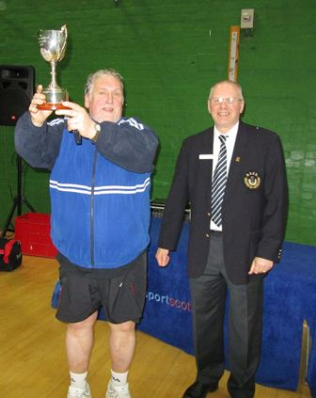
The West is Top League - Inter-League 30 March-1 April 2012, Inverclyde National Sports Centre. The West teams won four titles at the recent Inter-League and also retained the Stewart McGowan Trophy for the most successful League at the competition.
The following titles were won - Minor Girls, Cadet Girls, Junior Boys, and Veteran Men and runners up in the Cadet and Minor Boys’ events.

>> Photos

West players at the Worlds
Congratulations to Sean Doherty, Lynda Flaws and Corinna Whitaker for being selected to represent Scotland at the World Team Championships, Dortmund, Germany.
West Schools Results
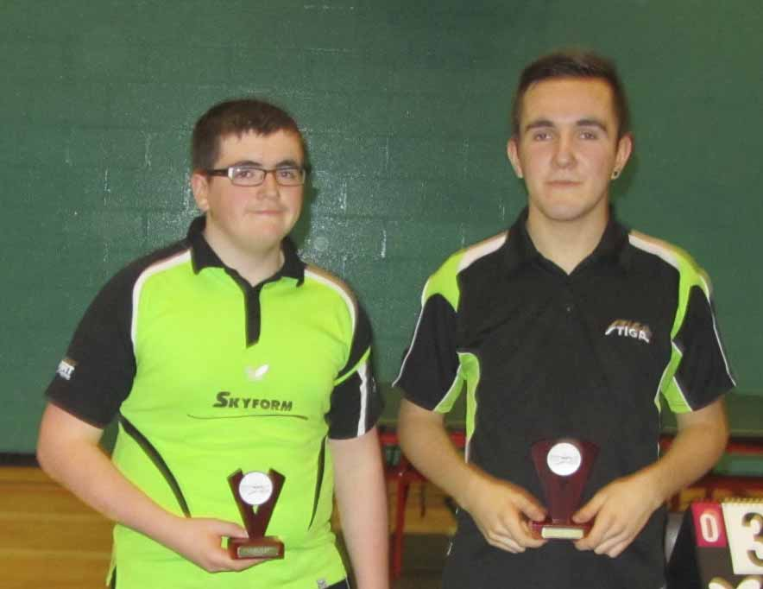
The West Schools qualification tournament took place at Drumchapel High School on Saturday 4 Feb - the top four players in the under 14, 16 and 18 events all qualify for the Scottish Schools Championships which take place on Sunday 26 Feb at Meadowmill Sports Centre, Tranent EH33 1LZ
Gallery>>
Results
Event | Winner | Runner-Up
Under 12 Girls | Emma Rhind | Jennie Yang
Under 12 Boys | Allan Woodhouse | Shreenil Vani
Under 14 Girls | Nadia Doherty | Claire Rankin
Under 14 Boys | Yaser Razouk | Greg Robertson
Under 16 Girls | Caitlin Cameron | Carla Rankin
Under 16 Boys | Connor Moran | Thomas Cairns
Open Doubles | Yazer Razouk &  Greg Robertson | Ross Grant &  Cameron Hussain

West Open Results
Ryan Jenkins (Wales) took his eighth title at the West of Scotland Open (Scotstoun) on Saturday 28 Jan. He beat Niall Cameron (Scotland) in the final by 3/1. Niall had 2 good wins, beating Gergely Urban (Hun) 3/1 in the semi-final, and the number 2 seed Craig Howieson 3/1 in the quarter final. In the other semi-final Calum Main was beaten 3/1 by Ryan.
Naomi Owen (Wales) claimed her 3rd title ladies title, winning against Aurelie Bernadet (France) 4/0. Gillian Edwards put up a good fight against Naomi in the semi-final, losing by 2/3 and Roxanna Milne lost in the other semi to Aurelie by 1/3.
In the Junior Events on Sunday, there were wins for Scott Barton (Junior Boys), Christopher Wheeler (Cadet and Minor Boys), Lucy Elliott (Junior and Cadet Girls) and Nadia Doherty (Minor Girls).
Men’s Singles  Ryan Jenkins (Wales) bt Niall Cameron 4/1 | Ladies Singles  Naomi Owen (Wales) bt Aurelie Bernadet (France) 4/0
Men’s Doubles  Crawford/Howieson bt R.Main/C. Main 3/1 | Ladies Doubles  Bernadet/Kravchenko bt Edwards/Milne 3/1
Men’s Band 1  D O’Connell (Wales) bt A Barella (Eng) 3/2 | Men’s Band 2  Alex Wheeler bt Yaser Razouk 3/1
Ladies Band 1  Linda McLernon bt K Petravistaite 3/0 | Hardbat Championships  Craig Hardie bt Charlie Brown 2/0
Veteran Singles  Peter Cameron bt Neil Doherty 3/0 | Standing disabilities  Conor Gordon bt Kevin McCormack 3/0
Under 21  Dan O’Connell bt Scott Barton 3/0 | Junior Boys  Scott Barton bt Colin Dalgleish 3/0
Junior Girls  Lucy Elliott bt Renee Ho 3/2 | Cadet Boys  Christopher Wheeler bt Jac Jenkins (Wales) 3/0
Cadet Girls  Lucy Elliott bt Rachel Crawford 3/0 | Minor Boys  Christopher Wheeler bt Jac Jenkins (Wales) 3/0
Minor Girls
Nadia Doherty bt Emma Rhind 3/0

