 | Premier | P | W | L | F | A
1 | North Ayrshire | 14 | 14 | 0 | 60 | 10
2 | Drum A | 14 | 12 | 2 | 47 | 23
3 | Drum B | 14 | 9 | 5 | 45 | 25
4 | Drum C | 14 | 8 | 6 | 37 | 33
5 | Greenock | 14 | 5 | 9 | 33 | 37
6 | South Ayrshire | 14 | 6 | 8 | 30 | 40
7 | Drum D | 14 | 1 | 13 | 16 | 54
8 | GSC A | 14 | 1 | 13 | 12 | 58
 | First Division | P | W | L | F | A
1 | Drumchapel E | 22 | 20 | 2 | 158 | 40
2 | Knightswood A | 22 | 20 | 2 | 141 | 57
3 | Nomads | 22 | 14 | 8 | 127 | 71
4 | Coatbridge | 22 | 15 | 7 | 118 | 80
5 | GSC B | 22 | 15 | 7 | 106 | 92
6 | South Ayrshire B | 22 | 11 | 11 | 98 | 100
7 | Kilwinning A | 22 | 11 | 11 | 97 | 101
8 | Drumchapel F | 22 | 8 | 14 | 84 | 114
9 | Garnethill | 22 | 6 | 16 | 74 | 124
10 | Mearns RBL | 22 | 6 | 16 | 70 | 128
11 | Carluke | 22 | 6 | 16 | 68 | 130
12 | Brunswick A | 22 | 0 | 22 | 47 | 151
 | Second Division | P | W | L | F | A
1 | 44th BB | 22 | 20 | 2 | 154 | 44
2 | Drumchapel G | 22 | 20 | 2 | 143 | 55
3 | Maccabi A | 22 | 16 | 6 | 120 | 78
4 | Kilwinning B | 22 | 13 | 9 | 118 | 80
5 | Knightswood B | 22 | 14 | 8 | 116 | 82
6 | Holy Cross HS | 22 | 12 | 10 | 102 | 96
7 | Castlemilk | 22 | 11 | 11 | 98 | 100
8 | Brunswick C | 22 | 7 | 15 | 77 | 121
9 | Brunswick B | 22 | 7 | 15 | 76 | 122
10 | GSC C | 22 | 7 | 15 | 74 | 124
11 | Maccabi B | 22 | 5 | 17 | 68 | 130
12 | Easterhouse | 22 | 0 | 22 | 42 | 156

Premier
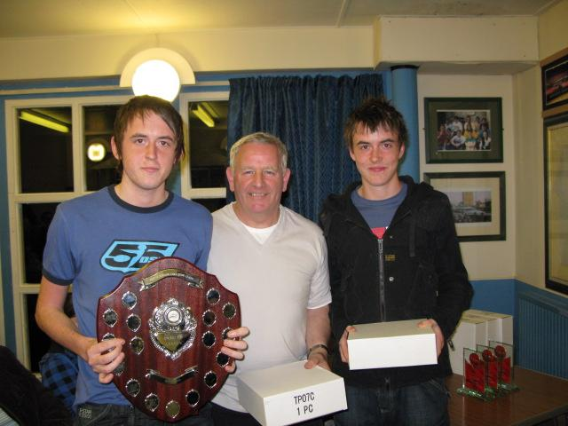
North Ayrshire retained the Premier League title from Drumchapel A. The North Ayrshire duo of Richard and Chris Main won all their matches with Richard sharing the top player award with Craig Hardie of Drumchapel A. Richard’s brother, Chris was third closely followed by Sean Doherty (Drumchapel B). At the other end of the table Glasgow Students, without a settled team all season, face relegation.

Division 1

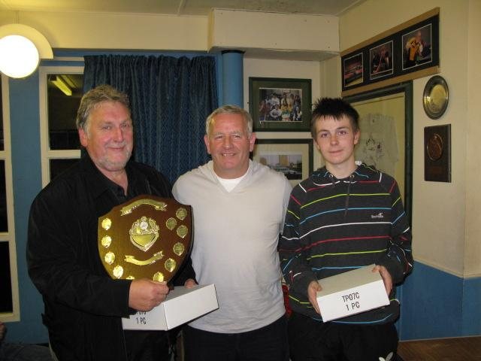
Drumchapel E achieved the league and cup double this season beating Knightswood A to both titles. Scott Barton and Nathan Courtney were the leading lights in this team with Scott producing a perfect average - played 57 and won 57. Nathan was not far behind on 87% and David McDonald was a very consistent number three with a highly respectable 75% average. Other leading players in this division were the redoubtable Roy Claxton of South Ayrshire, who played the second half of the season undefeated and Dimo Schallenh and Neil Doherty of Knightswood A. Clear in third spot were Nomads, fourteen points behind Knightswood.
At the other end of the table Brunswick A are relegated and Carluke face a play-off with Drumchapel G from the Second Division.

Division 2

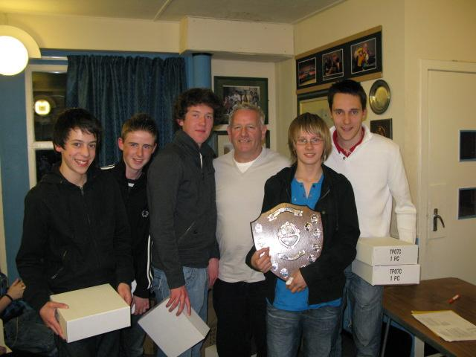
Having a strong pool of young players the 44th BB won the 2nd division by a good margin. Adam Gaffney was their leading player followed by Sam Murdoch, Philip Houston, Derek Paterson and Andrew Grant. They all ended up in the top half of the averages. Basel Razouk had a great season with Drumchapel ‘G’ winning 59 from the 61 games he played.

At the other end of the league the young Easterhouse team, who perhaps felt out of their depth at times, did well and lasted the course of the league. They certainly improved by the end of the season and we hope they will carry on playing, if not in the senior league then maybe in the Junior League.

Roll of Honour

Maxwell Wilson Cup  Winners – Drumchapel E  Runners Up – Knightswood A | House of Harris Cup  Winners – Holy Cross High School  Runners Up – 44th BB
Walter McNeil Cup (Handicap)  Winners – Nomads  Runners Up – Mearns RBL | Top Players  Premier – Richard Main & Craig Hardie  Division 1 – Scott Barton  Division 2 – Bazel Razouk
Players of the Year  Senior - Corinna Whitaker  Junior – Sean Doherty  Cadet – Scott Barton  Minor – Lucy Elliot | Players’ Player  Division 1 Joint Winners -  Derek Steele & Duncan MacKenzie  Division 2 - Malcolm Cuthbertson

Junior League Roundup
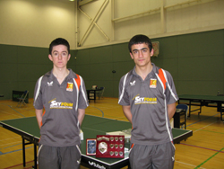
The Junior League reached its climax at the weekend and over the four sessions produced plenty of exciting play. Division One developed a familiar scenario with Drumchapel and Holyrood fighting it out for top spot. As in the previous two years Drumchapel ran out worthy winners without dropping a game although both Holyrood teams did extend some of the matches to five ends. Congratulations to Drumchapel A - Graeme Donnelly and Bazel Razouk - at securing the title, maintaining their form and sharing the top player award. So it’s more of the same for the ‘Drum’ and back to the drawing board for Holyrood but they should take some credit at securing second and third place in the top division.

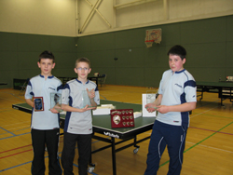
North Ayrshire C’s success in Division Two was almost as impressive as Drumchapel’s efforts, winning all their matches but dropping a few games along the way. Their team of Andrew McPherson, Chris Barclay and David Shanks took the top three positions in the averages and congratulations to Andrew in securing the top player award. In a very tight finish for second place, the all girl Drumchapel C team did well to take it with just two points separating them from East Kilbride B and Holyrood E.

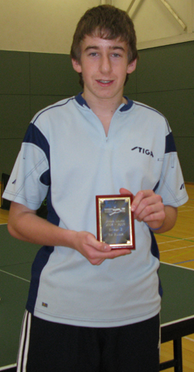
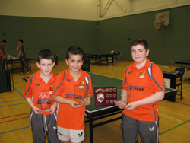
Division Three produced the closest finish with Drumchaple D winning the title by one point from North Ayrshire F. Knightswood C nearly spoilt Drumchapel’s charge to the title but Yaser Razouk won the crucial final match. Congratulations to Yaser, Thomas Cairns and Greg Robertson of Drumchapel D on winning their first league title. North Ayrshire F’s Jordan McGinlay took some comfort in winning the division’s top player award, well done Jordan.

Minor League
The finals of our new Minor League took place on Saturday 21st March at Drumchapel High School.
The winners were:

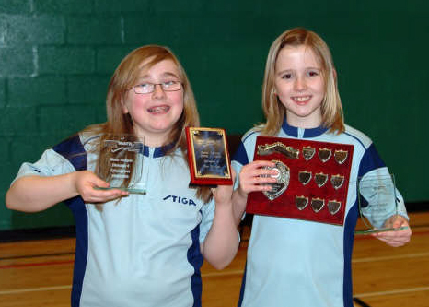 | 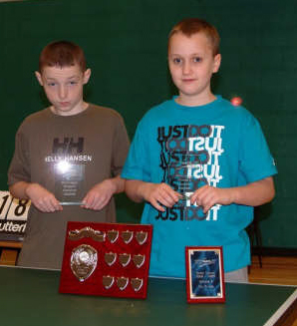 | 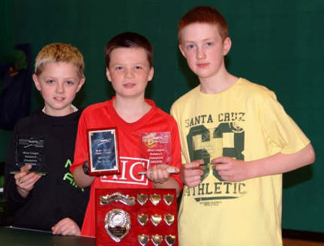
Division 4: North Ayrshire | Division 5: Easterhouse | Division 6: Bankhead Primary

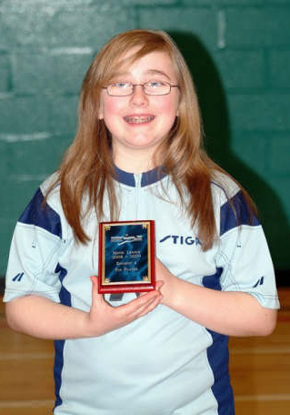 | 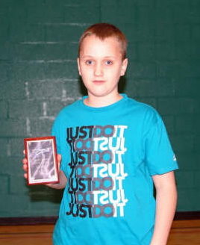 | 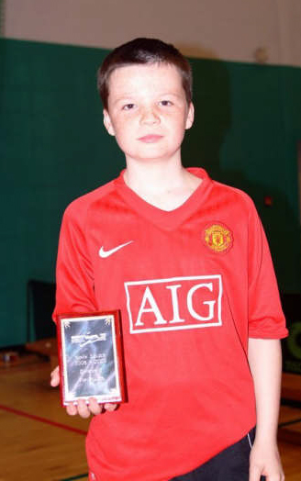
D4 Top Player  Katie Hannah | D5 Top Player  Paul Cochrane | D6 Top Player  Corey Pearson

Congratulations to all teams and thanks to Alex Hardie and Malcolm Smith for organising the league and keeping us all up-to-date with the results. I hope we see a few of the players turning out for the Junior league next season.
West Open Day 1

The 2009 West of Scotland Open, Scotland’s premier tournament, took place on Saturday 31st January & Sunday 1st February. It attracted a high quality entry including the top ranked national players along with Welsh wizard and 5 times Men’s Singles champion – Ryan Jenkins and Chinese sensation Lei Shu. There were also squads from Ulster, Dublin and Wales.

Men’s Singles

Seven of the top seeds made it through to the quarter finals in the Men’s singles event, with Gerry Campbell being the only casualty.

Quarter Finals

Ryan Jenkins (Wales) beat Craig Hardie (Glasgow) 3-0
Gavin Rumgay (Perth) beat Sean Doherty (Glasgow) 3-1
Stewart Crawford (Falkirk) beat Niall Cameron (London) 3-0
Lei Shu (China) beat Craig Howieson (Edinburgh) 3-0

Semi Finals

The semi finals were action packed and watched by a large crowd.

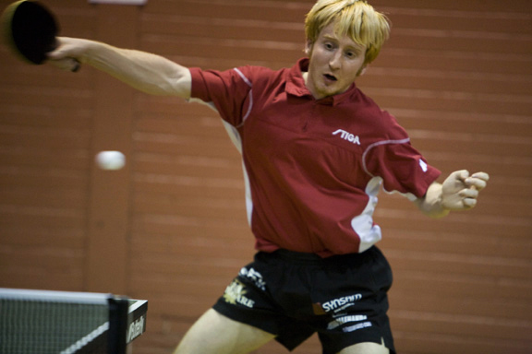
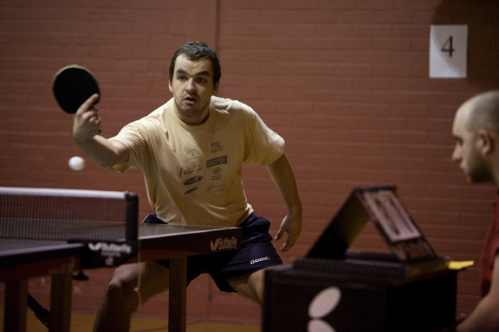
The first semi-final saw Ryan Jenkins up against Scotland number 1 Gavin Rumgay. Ryan raced to a lead in the first two sets only to see Gavin regain the lead and take each end. This was to be Gavin’s day and he was a worthy winner securing the match 3-1 to reach the final. With the title holder out we would have a new champion – but who would it be?

The second semi final brought Stewart Crawford up against Lei Shu. Stewart played some powerful shots, but Lei Shu was able to control them and then apply his own winning strategy, winning 3-0 to reach the final.

Final

So the scene was set for the 2009 Men’s singles final. Gavin started off well coping with Lei Shu’s topspins and they traded loop to loop rallies but Lei more often than not played that extra shot to win the point. In the last two ends Lei changed his serve to a very innocuous looking back hand serve – or what appeared innocuous! This gave Lei an advantage in his opening attack and with Gavin trying to cope with cramp Lei went on to secure a 4-1 win and the title.

Ladies Singles

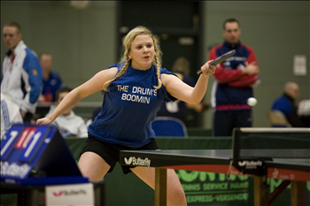
A high standard was set in the ladies event. Leading the ladies was defending champion Jenny Weiss, who had just won the Lothian’s Ladies title the week before.

There were plenty of shocks along the way in this competition, starting with Josie Bruce winning her group, beating Scottish number 2 Gillian Edwards, then beating former Scottish Champion Rebecca Russell, Josie’s run came to an end at the hand of Jenny losing 0-3.

Perhaps one of the best matches in this event was the quarter final between Jenny Weiss and Natasha Milliken. This was a battle of the left handers, and both players went all out attack, in the end Jenny used her experience to gain the upper hand winning the match 3-2.

In the final, a repeat of last year’s final, Jenny retained her title beating Amanda Mogey (Ulster) 4-0.

Mens Doubles

The men’s doubles was a very high standard, with top seeds Gavin Rumgay / Niall Cameron reaching the final with wins against Callum Main/ Callum Morgan, Gerry Campbell/ Stuart Fowler, Craig Hardie/ Sean Doherty.

In the other half of the draw, Stewart Crawford / Craig Howieson came through with wins against Scott Johnston/ Jonny Gregory, Richard Main/ Chris Main, Ryan Jenkins/ Patrick Thomas.

In the final Stewart and Craig won a five set thriller against Gavin and Niall.

Ladies Doubles

In the ladies doubles event Corinna Whitaker and Natasha Milliken reached the final with a good win against Amanda Mogey and Ashley Givan. In the other half of the draw Gillian Edwards and Elaine Forbes came through after a five set tussle with Jenny Weiss and Josie Bruce.

In the final Gillian and Elaine managed to get the better of their younger opponents, winning 3-1.

Ladies Band 1

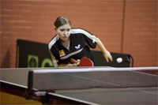
This event provided a few surpise results; Stephanie McCallum secured good wins against Maureen Moran and then against Scottish junior number 2 Lynda Flaws. Her run came to an end at the semi final stage losing to Charlotte Cairey 3-1.

Ashley Givan was also making good progress in the bottom half of the draw beating Sadie Edwards, then securing good wins against Josie Bruce and Rhian Williams.

In the final Charlotte held on to win 11-9 in the final set against Ashley.

Mens Band 1

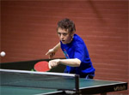
This event produced plenty of exciting matches. Luc Leboutillar (Edinburgh) reached the final with victories over L.Oseni (Ireland) and Scott Johnston (Auchterarder).

In the bottom half of the draw Chris Main (Saltcoats) reached the final with wins against Blair Fowler (Falkirk), Andy McFadyen (Glasgow), and Alan McCarry (Ayr).

In the final, both players produced some tremendous rallies and as the clock struck 8pm Chris secured the win, 11-7 in the final set.

West Open Day 2

Under 21 singles
In the group stage Richard Main (Saltcoats) survived a scare, going down 0-2 to Nathan Courtney (Drumchapel) before recovering strongly to win 3-2.

Patrick Thomas (Wales) secured wins over Calum Main (Eaglesfield) and Ashley Robinson (Ulster) to meet Tom Maynard (England) who had wins against Myles Collins (England) and Richard Main (Saltcoats).

Patrick showed his class winning an entertaining match 3-1.

Junior Boys Singles

Patrick Thomas maintained his form to reach the final. He beat Colin Dalgleish (Edinburgh), Myles Collins (England) and Scott Barton (Glasgow).

The ever improving Scott Barton can be pleased at reaching the semi finals of this event, losing out to Patrick 3-1.

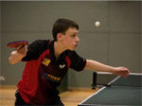
Sean Doherty (Glasgow) had wins over Liam O’Shaunessy (Dumfries), Ashley Robinson (Ulster) and in a tremendous semi final Callum Morgan (Dumfries).

In the final, Patrick raced to a two nil lead, but Sean recovered and won the next two sets to restore parity. Patrick however used all his experience to win the final set and the title.
Junior Girls

Natasha Milliken continued her good form from the previous day to reach the final of this event; she had a tough semi final match against Ashley Givan (Ulster) winning 3-2.

Charlotte Cairey secured the other final slot with wins against Roisin O’ Reilly and Rebecca Irwin.

In a roller coaster match Charlotte went two nil up, but Natasha responded well and won the next two sets. In an extremely tight fifth set Charlotte kept her nerve winning 12-10.

Cadet Boys

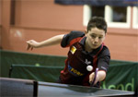
Liam O’Shaughnessy with good wins against Jonathan Porter, Garry Wright and Stephen Slater faced Scott Barton who had solid wins over Robbie Fairley, Chris Wheeler and Colin Dalgleish.

Scott confirmed his steady improvement by winning his first West Open title, beating Liam 3-1.

Cadet Girls

Charlotte Cairey (Wales) secured a hat trick of titles by winning the cadet girls event, she beat Ciara Hayes, Emma Ludlow and then Ashley Givan.

Minor Boys

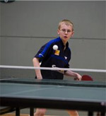
Blair Fowler (Falkirk) secured a final spot with wins against Ryan Howells and Conor Mullaly. In the semi finals he faced club mate Chris Wheeler. This was one of the most exciting matches of the day and both players played some spectacular table tennis. Blair went 2-0 up only for Chris to win the next two sets. Blair eventually won 11-8 in the final set.

Adam Gaffney successfully manoeuvred through the other half of the draw with wins against Alasdair Rennet, Alex Prosser and Ying Jin.

Blair was still flying after his semi final victory and raced through the first two sets. Adam battled back to win the third, but Blair held on to win the match 3-1.

Minor Girls

There were shocks in the minor girl’s event. Top seed Alice Williams lost out to Laura Finn (Ulster) in the group stage but came back strongly to reach the final and secure a quick revenge beating Laura 3-2.

