2006/2007
Premier
 | P | W | L | F | A | Points
1 Drum A | 14 | 12 | 2 | 50 | 20 | 50
2 Greenock | 13 | 7 | 6 | 40 | 25 | 40
3 Holyrood | 12 | 7 | 5 | 36 | 24 | 36
4 Prestwick | 12 | 6 | 6 | 32 | 28 | 32
5 Young Ones | 12 | 7 | 5 | 29 | 31 | 29
6 Drum Vets | 14 | 5 | 9 | 25 | 45 | 25
7 Kilwinning | 13 | 4 | 9 | 24 | 41 | 24
8 Drum B | 14 | 4 | 10 | 24 | 46 | 24

Division 1
 | P | W | L | F | A
1 Drumchapel C | 22 | 17 | 5 | 136 | 62
2 Gl`w Students Coll. A | 22 | 17 | 5 | 132 | 66
3 Kilwinning A | 22 | 11 | 11 | 113 | 85
4 Coatbridge | 22 | 15 | 7 | 113 | 85
5 Carluke | 22 | 13 | 9 | 103 | 95
6 Motherwell | 22 | 13 | 9 | 98 | 100
7 Garnethill A | 22 | 11 | 11 | 95 | 103
8 Knightswood | 22 | 9 | 13 | 85 | 113
9 Drumchapel Ladies | 22 | 8 | 14 | 81 | 117
10 Boys` Brigade 44th | 22 | 5 | 17 | 79 | 119
11 Airdrie | 22 | 7 | 15 | 77 | 121
12 Maccabi | 22 | 6 | 16 | 76 | 122

Division 2
 | P | W | L | F | A
1 Mearns RBL | 22 | 20 | 2 | 152 | 46
2 Gl`w Students Coll. B | 22 | 18 | 4 | 130 | 68
3 Holy Cross HS | 22 | 16 | 6 | 126 | 72
4 Kilwinning B | 22 | 13 | 9 | 123 | 75
5 Brunswick B | 22 | 14 | 8 | 112 | 86
6 Garnethill B | 21 | 10 | 11 | 102 | 87
7 South Ayrshire TTC | 21 | 13 | 8 | 100 | 89
8 Brunswick A | 22 | 11 | 11 | 99 | 99
9 Scottish Power | 22 | 7 | 15 | 89 | 109
10 Drumchapel D | 22 | 6 | 16 | 66 | 132
11 Brunswick C | 22 | 3 | 19 | 42 | 156
12 Gl'w Students | 22 | 0 | 22 | 38 | 160
CUPS

Maxwell Wilson - Division 1

Semi Final | Final

GSC A | 5
Carluke | 1 | GSC A | 5
Knightswood | 0 | Drumchapel C | 4
Drumchapel C | 5

House of Harris - Division 2

Semi Final | Final

Holy X HS | 4
South Ayr | 5 | South Ayr | 5
Brunswick B | 2 | Mearns | 2
Mearns RBL | 5

Walter Mcneil Memeorial Handicap Trophy

Semi Final | Final

Garnethill A won by | 3 pts
Carluke | 3 pts | GSC A won by | 51
GSC A won | 68 pts | Garnethill A | 51
Coatbridge | 68 pts

Junior League
Division 1
 | P | W | L | F | A | Points
1 Drumchapel | 7 | 6 | 1 | 30 | 5 | 30
2 Holyrood A | 7 | 7 | 0 | 29 | 6 | 29
3 Drumchapel H S | 7 | 4 | 3 | 24 | 11 | 24
4= Holyrood B | 7 | 4 | 3 | 18 | 17 | 18
4=Jubilee All Stars | 7 | 3 | 4 | 18 | 17 | 18
6 East Kilbride | 7 | 2 | 5 | 10 | 25 | 10
7 Bishopbriggs | 7 | 1 | 6 | 7 | 28 | 7
8 North Ayrshire | 7 | 1 | 6 | 4 | 31 | 4

Division 2
 | P | W | L | F | A | Points
1 Holyrood 1 | 8 | 6 | 2 | 29 | 11 | 29
2 Drumchapel | 8 | 5 | 3 | 26 | 14 | 26
3 Holyrood 2 | 8 | 6 | 2 | 25 | 15 | 25
4= North Ayrshire 2 | 8 | 5 | 3 | 24 | 16 | 24
4= 44th BB | 8 | 5 | 3 | 24 | 16 | 24
6 278th BB | 8 | 2 | 6 | 16 | 24 | 16
7= East Kilbride | 8 | 2 | 6 | 15 | 25 | 15
7= North Ayrshire 1 | 8 | 3 | 5 | 15 | 25 | 15
9 Rosshall Ac | 8 | 2 | 6 | 6 | 34 | 6

Division 3
 | P | W | L | F | A | Points
1 Holyrood | 8 | 8 | 0 | 36 | 4 | 36
2= North Ayrshire A | 8 | 7 | 1 | 29 | 11 | 29
2= East Kilbride B | 8 | 6 | 2 | 29 | 11 | 29
4 278th BB | 8 | 4 | 4 | 21 | 19 | 21
5 Drumchapel | 8 | 3 | 5 | 17 | 23 | 17
6 East Kilbride C | 8 | 1 | 7 | 16 | 24 | 16
7= 44th BB | 8 | 3 | 5 | 12 | 28 | 12
7= North Ayrshire B | 8 | 2 | 6 | 12 | 28 | 12
9 East Kilbride A | 8 | 2 | 6 | 8 | 32 | 8
West Open 2007
The West of Scotland Open took place at Holyrood Sports Centre, Glasgow over the weekend of 20-21 January. Now established as the premier tournament in the Scottish calendar, it attracted a large international entry and produced many exciting matches over the two days of competition.

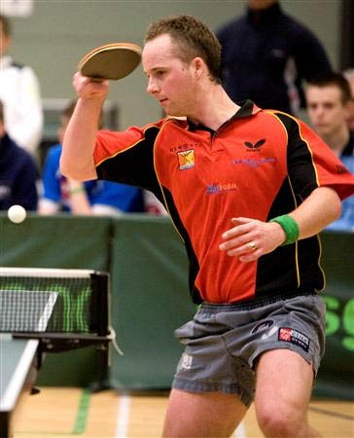
Ryan Jenkins (Wales) retained the men’s singles title and has now won four men’s titles in a row. In a high quality final, Ryan was made to work hard for his 6 set victory against Scottish Number 1 Gavin Rumgay. Earlier, in the semi-finals, Ryan and Gavin came through against Scottish and Welsh Number 3s Niall Cameron and Stephen Jenkins respectively.

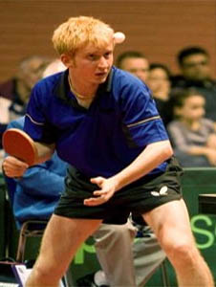
Gavin made an excellent start in the final with some very impressive third ball attacks and took the first 11-6. Ryan then got into his stride and won the next two ends 9 and 6. The large crowd was really enjoying a very open and entertaining final. Gavin replied strongly with some tenacious play and took the fourth 11-8 but Ryan was not to be denied and with very impressive counter attacking from both wings, he eventually out manoeuvred Gavin 8 and 6 in the final two ends.
Ryan Jenkins won 6-11, 11-9, 11-6, 8-11, 11-8, 11-6.

The ladies final brought together Hartlepool based Chinese Junior girls Xu Shu-Ying (Katie) and Lui Meihan (Maria).
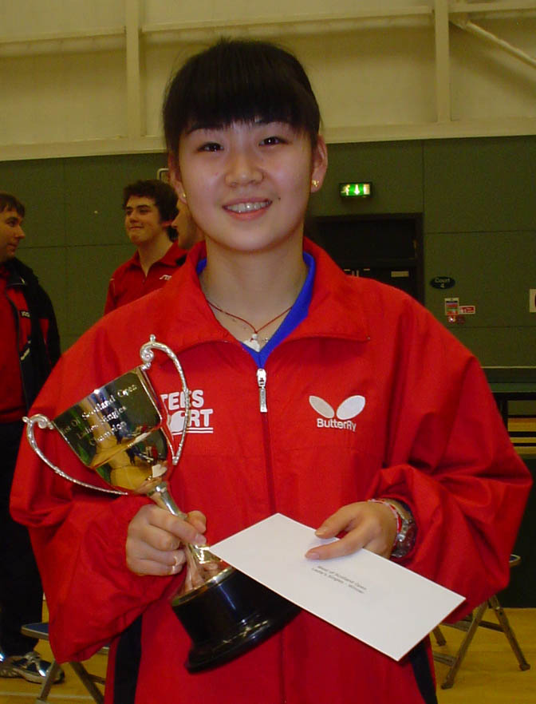
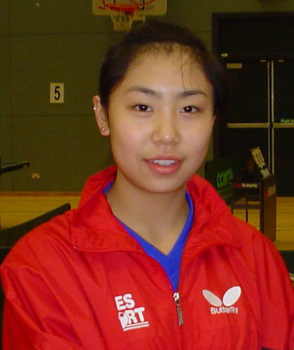
In the semi finals Xu Shu-Ying accounted for Scottish Number 4 Corrina Whitaker and Lui Meihan came through against Laure Bordanneau from France. In the final Xu Shu-Ying gave a master class in attack against defence and won in four straight sets against her Chinese compatriot.

Xu Shu-Ying won 11-5, 11-3, 11-5, 11-3
Notable results for West players included Richard Main reaching the final of the Men’s Band 1 losing out to Nikolas Vittel of France. Linda Horsefield won the Band 1 Ladies and Daniel Swiatek and Natasha Milliken won the Boys and Girls cadet titles. Craig Hardie was runner-up in the Junior Boys singles and our very own Match Secretary, Michael Schoenhofen had a great run in the Vets singles losing out in the semi-finals, in three close ends, to the eventual winner Darren McVittie of Hartlepool.
Event | Player |  |  | Result
Men’s Singles | Ryan Jenkins (Wales) | bt | Gavin Rumgay (Scotland) | –6,9,6,-8,8,6
Ladies Singles | Xu Shu Ying (Hartlepool) | bt | Liu Meihan (Hartlepool) | 5, 3, 5, 3
Men’s Band 1 | Nikolas Vittel (France) | bt | Richard Main (WoS)
Ladies Band 1 | Linda Horsfield (WoS) | bt | Catherine Symonds (Orkney)
U21 | Craig Howieson | bt | Xu Shu Ying | 7,9,-5,-12,9
Vets | Darren McVitie (Hartlepool) | bt | Willie Mabon (Edinburgh) | 3-0
U18 Boys | Craig Howieson (Edinburgh) | bt | Craig Hardie (WoS) | 3-1
U18 Girls | Liu Meihan (Hartlepool) | bt | Natasha Milliken (WoS) | 3-0
U15 Boys | Daniel Swiatek (WoS) | bt | Sam Hanley (Dublin) | 3-0
U15 Girls | Natasha Miliken (WoS) | w/o | Judith Atwell (Ulster)
U13 Boys | Liam O’Shaughnessy | bt | Peter McConnell (Ulster)
U13 Girls | Ashley Givan (Ulster) | bt | Lynda Flaws (Shetland)
Junior Boys B1 | Callum Morgan (Dumfries) | bt | Maciek Zcymanski (Dublin)
Junior Girls B1 | Clodagh McCullagh (Ireland) | bt | Rhian Willaims (Dumfries)

2006/2007
National Champions
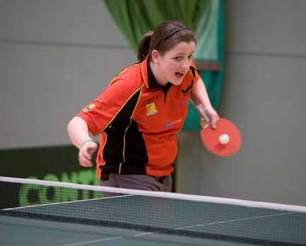
The West of Scotland has 4 National Champions:
George Johnston – over 60’s Champion
Corinna Whitaker – National Junior Girls Champion
Natasha Milliken – National Cadet Girls Champion
Craig Hardie – National Junior Doubles Champion

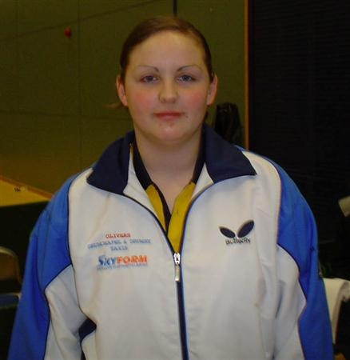
We also have three junior players ranked Scottish No 1: Natasha Milliken – Cadet Girls; Sean Doherty – Cadet Boys and Corinna Whitaker – Junior Girls

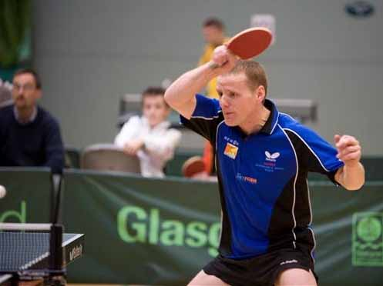
International Selections
Three players have been selected to represent Scotland at the up and coming Commonwealth Table Tennis Championships in India – Gordon Clancey, Corinna Whitaker and Natasha Milliken.

Inter League
We had 14 teams competing in all the categories, winning two (Mens and Junior Girls) and runners up in four (Minor, Cadet and Junior Boys and Veterans)

